NSW Syllabus

Modern History
Life Skills

Stage 6

Syllabus

© 2017 NSW Education Standards Authority (NESA) for and on behalf of the Crown in right of the State of New South Wales.

The NESA website holds the ONLY official and up-to-date versions of these documents available on the internet. ANY other copies of these documents, or parts of these documents, that may be found elsewhere on the internet might not be current and are NOT authorised. You CANNOT rely on copies from any other source.

The documents on this website contain material prepared by NESA for and on behalf of the Crown in right of the State of New South Wales. The material is protected by Crown copyright.

All rights reserved. No part of the Material may be reproduced in Australia or in any other country by any process, electronic or otherwise, in any material form, or transmitted to any other person or stored electronically in any form without the prior written permission of NESA, except as permitted by the Copyright Act 1968.

When you access the material you agree:
- to use the material for information purposes only
- to reproduce a single copy for personal bona fide study use only and not to reproduce any major extract or the entire material without the prior permission of NESA.
- to acknowledge that the material is provided by NESA.
- to include this copyright notice in any copy made
- not to modify the material or any part of the material without the express prior written permission of NESA.
The material may contain third-party copyright materials such as photos, diagrams, quotations, cartoons and artworks. These materials are protected by Australian and international copyright laws and may not be reproduced or transmitted in any format without the copyright owner’s specific permission. Unauthorised reproduction, transmission or commercial use of such copyright materials may result in prosecution.

NESA has made all reasonable attempts to locate owners of third-party copyright material and invites anyone from whom permission has not been sought to contact the Copyright Officer.

Phone: (02) 9367 8289
Fax: (02) 9279 1482
Email: copyright@nesa.nsw.edu.au

Published by
NSW Education Standards Authority
GPO Box 5300
Sydney NSW 2001
Australia

www.educationstandards.nsw.edu.au

DSSP–27617
D2016/57589

Contents
Introduction 4
Modern History Life Skills Key 7
Modern History Life Skills Stage 6 9
Rationale 10
The Place of the Modern History Life Skills Stage 6 Syllabus in the K–12 Curriculum 11
Aim 12
Objectives 13
Outcomes 14
Course Structure 18
Assessment and Reporting 19
Content 20
Modern History Life Skills Course Content 26
Glossary 50

Introduction

Stage 6 Curriculum
NSW Education Standards Authority (NESA) Stage 6 syllabuses have been developed to provide students with opportunities to further develop skills which will assist in the next stage of their lives.

The purpose of Stage 6 syllabuses is to:
- develop a solid foundation of literacy and numeracy
- provide a curriculum structure which encourages students to complete secondary education at their highest possible level
- foster the intellectual, creative, ethical and social development of students, in particular relating to:
  - application of knowledge, skills, understanding, values and attitudes in the fields of study they choose
  - capacity to manage their own learning and to become flexible, independent thinkers, problem-solvers and decision-makers
  - capacity to work collaboratively with others
  - respect for the cultural diversity of Australian society
  - desire to continue learning in formal or informal settings after school
- provide a flexible structure within which students can meet the challenges of and prepare for:
  - further academic study, vocational training and employment
  - changing workplaces, including an increasingly STEM focused (Science, Technology, Engineering and Mathematics) workforce
  - full and active participation as global citizens
- provide formal assessment and certification of students’ achievements
- promote the development of students’ values, identity and self-respect.

The Stage 6 syllabuses reflect the principles of the NESA K–10 Curriculum Framework and Statement of Equity Principles, the reforms of the NSW Government Stronger HSC Standards (2016), and nationally agreed educational goals. These syllabuses build on the continuum of learning developed in the K–10 syllabuses.

The syllabuses provide a set of broad learning outcomes that summarise the knowledge, understanding, skills, values and attitudes important for students to succeed in and beyond their schooling. In particular, the attainment of skills in literacy and numeracy needed for further study, employment and active participation in society are provided in the syllabuses in alignment with the Australian Core Skills Framework (ACSF).

The Stage 6 syllabuses include the content of the Australian curriculum and additional descriptions that clarify the scope and depth of learning in each subject.

NESA syllabuses support a standards-referenced approach to assessment by detailing the important knowledge, understanding, skills, values and attitudes students will develop and outlining clear standards of what students are expected to know and be able to do. The syllabuses take into account the diverse needs of all students and provide structures and processes by which teachers can provide continuity of study for all students.

Diversity of Learners
NSW Stage 6 syllabuses are inclusive of the learning needs of all students. Syllabuses accommodate teaching approaches that support student diversity including students with special education needs, gifted and talented students, and students learning English as an additional language or dialect (EAL/D). Students may have more than one learning need.

Students with Special Education Needs
All students are entitled to participate in and progress through the curriculum. Schools are required to provide additional support or adjustments to teaching, learning and assessment activities for some students with special education needs. Adjustments are measures or actions taken in relation to teaching, learning and assessment that enable a student with special education needs to access syllabus outcomes and content, and demonstrate achievement of outcomes.

Students with special education needs can access the outcomes and content from Stage 6 syllabuses in a range of ways. Students may engage with:
- Stage 6 syllabus outcomes and content with adjustments to teaching, learning and/or assessment activities; or
- selected Stage 6 Life Skills outcomes and content from one or more Stage 6 Life Skills syllabuses.

Decisions regarding curriculum options, including adjustments, should be made in the context of collaborative curriculum planning with the student, parent/carer and other significant individuals to ensure that decisions are appropriate for the learning needs and priorities of individual students.

Further information can be found in support materials for:
- Modern History Life Skills
- Special education needs
- Life Skills.

Gifted and Talented Students
Gifted students have specific learning needs that may require adjustments to the pace, level and content of the curriculum. Differentiated educational opportunities assist in meeting the needs of gifted students.

Generally, gifted students demonstrate the following characteristics:
- the capacity to learn at faster rates
- the capacity to find and solve problems
- the capacity to make connections and manipulate abstract ideas.

There are different kinds and levels of giftedness. Gifted and talented students may also possess learning difficulties and/or disabilities that should be addressed when planning appropriate teaching, learning and assessment activities.

Curriculum strategies for gifted and talented students may include:
- differentiation: modifying the pace, level and content of teaching, learning and assessment activities
- acceleration: promoting a student to a level of study beyond their age group
- curriculum compacting: assessing a student’s current level of learning and addressing aspects of the curriculum that have not yet been mastered.

School decisions about appropriate strategies are generally collaborative and involve teachers, parents and students, with reference to documents and advice available from NESA and the education sectors.

Gifted and talented students may also benefit from individual planning to determine the curriculum options, as well as teaching, learning and assessment strategies, most suited to their needs and abilities.

Students Learning English as an Additional Language or Dialect (EAL/D)
Many students in Australian schools are learning English as an additional language or dialect (EAL/D). EAL/D students are those whose first language is a language or dialect other than Standard Australian English and who require additional support to assist them to develop English language proficiency.

EAL/D students come from diverse backgrounds and may include:
- overseas and Australian-born students whose first language is a language other than English, including creoles and related varieties
- Aboriginal and Torres Strait Islander students whose first language is Aboriginal English, including Kriol and related varieties.

EAL/D students enter Australian schools at different ages and stages of schooling and at different stages of English language learning. They have diverse talents and capabilities and a range of prior learning experiences and levels of literacy in their first language and in English. EAL/D students represent a significant and growing percentage of learners in NSW schools. For some, school is the only place they use Standard Australian English.

EAL/D students are simultaneously learning a new language and the knowledge, understanding and skills of the Modern History Life Skills Stage 6 Syllabus through that new language. They may require additional support, along with informed teaching that explicitly addresses their language needs.

The ESL Scales and the English as an Additional Language or Dialect: Teacher Resource provide information about the English language development phases of EAL/D students. These materials and other resources can be used to support the specific needs of English language learners and to assist students to access syllabus outcomes and content.

Modern History Life Skills Key
The following codes and icons are used in the Modern History Life Skills Stage 6 Syllabus.

Outcome Coding
Syllabus outcomes have been coded in a consistent way. The code identifies the subject, Year and outcome number. For example:

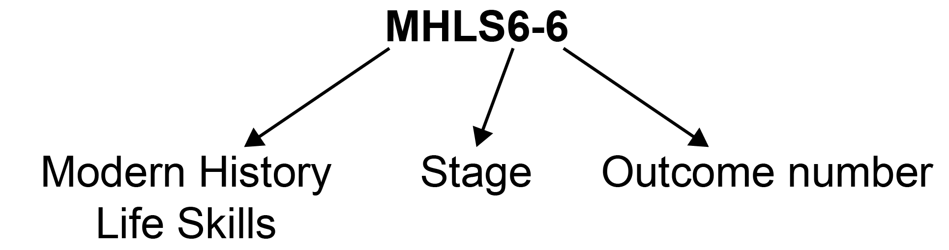

Outcome code | Interpretation
MHLS6-6 | Modern History Life Skills, Stage 6 – Outcome number 6
MH11-1 | Modern History, Year 11 – Outcome number 1
MH12-4 | Modern History, Year 12 – Outcome number 4

Learning Across the Curriculum Icons
Learning across the curriculum content, including cross-curriculum priorities, general capabilities and other areas identified as important learning for all students, is incorporated and identified by icons in the syllabus.

Cross-curriculum priorities
Aboriginal and Torres Strait Islander histories and cultures
Asia and Australia’s engagement with Asia
Sustainability

General capabilities
Critical and creative thinking
Ethical understanding
Information and communication technology capability
Intercultural understanding
Literacy
Numeracy
Personal and social capability

Other learning across the curriculum areas
Civics and citizenship
Difference and diversity
Work and enterprise

Modern History Life Skills Stage 6
The Modern History Life Skills Stage 6 Syllabus aligns with the rationale, aim, objectives and outcomes of the Modern History Stage 6 Syllabus. The Life Skills content has been developed from the Modern History syllabus to provide opportunities for integrated course delivery.

Before deciding that a student should undertake a course based on Life Skills outcomes and content, consideration should be given to other ways of assisting the student to engage with the regular course outcomes. This assistance may include a range of adjustments to the teaching, learning and assessment activities of the History Stage 6 curriculum.

If the adjustments do not provide a student with sufficient access to some or all of the Stage 6 outcomes, a decision can be explored for the student to undertake Life Skills outcomes and content. This decision should be made through the collaborative curriculum planning process involving the student and parent/carer and other significant individuals. School principals are responsible for the management of the collaborative curriculum planning process.

The following points need to be taken into consideration:
- students are not required to complete all Life Skills outcomes
- specific Life Skills outcomes should be selected based on the needs, strengths, goals, interests and prior learning of each student
- outcomes may be demonstrated independently or with support.

Further information in relation to planning, implementing and assessing Life Skills outcomes and content can be found in support materials for:
- Modern History Life Skills
- Special education needs
- Life Skills.

Rationale
The Modern History Life Skills Stage 6 Syllabus rationale is consistent with the Modern History Stage 6 Syllabus rationale. The Modern History rationale is provided below.

The study of Modern History engages students in an investigation of the forces that have shaped the world, based on the analysis and interpretation of sources. It offers students the opportunity to investigate the possible motivations and actions of individuals and groups, and how they have shaped the world politically, culturally, economically and socially. Modern History stimulates students’ curiosity and imagination, and enriches their appreciation of humanity by introducing them to a range of historical developments and experiences that have defined the modern world.

Modern History enables students to trace the historical background of contemporary issues and to explore the significance of individuals, ideas and events. It equips students with knowledge, understanding and skills to help them examine and make sense of the world around them.

The study of Modern History requires students to understand and use historical concepts and apply skills in their investigation of people, ideas, movements, events and developments of the modern world within personal, local, national, regional and global contexts. Students are introduced to the complexities associated with the changing nature of sources, their expanding quantity, range and form, and the distinctive characteristics of modern historical representation. Students are encouraged to interpret sources for evidence, establish which evidence is relevant to an inquiry, and use evidence to construct and analyse historical accounts.

Modern History provides students with opportunities to satisfy their interest and curiosity about people and events that have had a significant impact on the modern world. It provides insight into the possible motivations and role of individuals and groups as well as the origin and impact of ideas and developments that have transformed societies. It enables students to acquire knowledge and to understand how knowledge is constructed. Modern History provides opportunities for students to explore historical problems, to pose questions and to consider problems of evidence, causation and historical agency as part of the historical inquiry process, using the information technology available to them.

Students develop transferable skills associated with the process of historical inquiry and the interplay of historical evidence and argument. These include critical literacy skills, for example interpreting, analysing and weighing evidence; synthesising evidence from a variety of sources; developing reasoned and evidence-based arguments. Students develop increasingly sophisticated historiographical skills and historical understanding, from the close study of people and events to the analysis and interpretation of broader developments that have shaped the modern world.

The knowledge, understanding and skills that students acquire through studying Modern History provide a firm foundation for further study, the world of work, active and informed citizenship, and for lifelong learning. It fosters a critical approach to understanding events, issues and interpretations as well as the effective communication of accounts conveying ideas, judgements and evidence.

The Place of the Modern History Life Skills Stage 6 Syllabus in the K–12 Curriculum

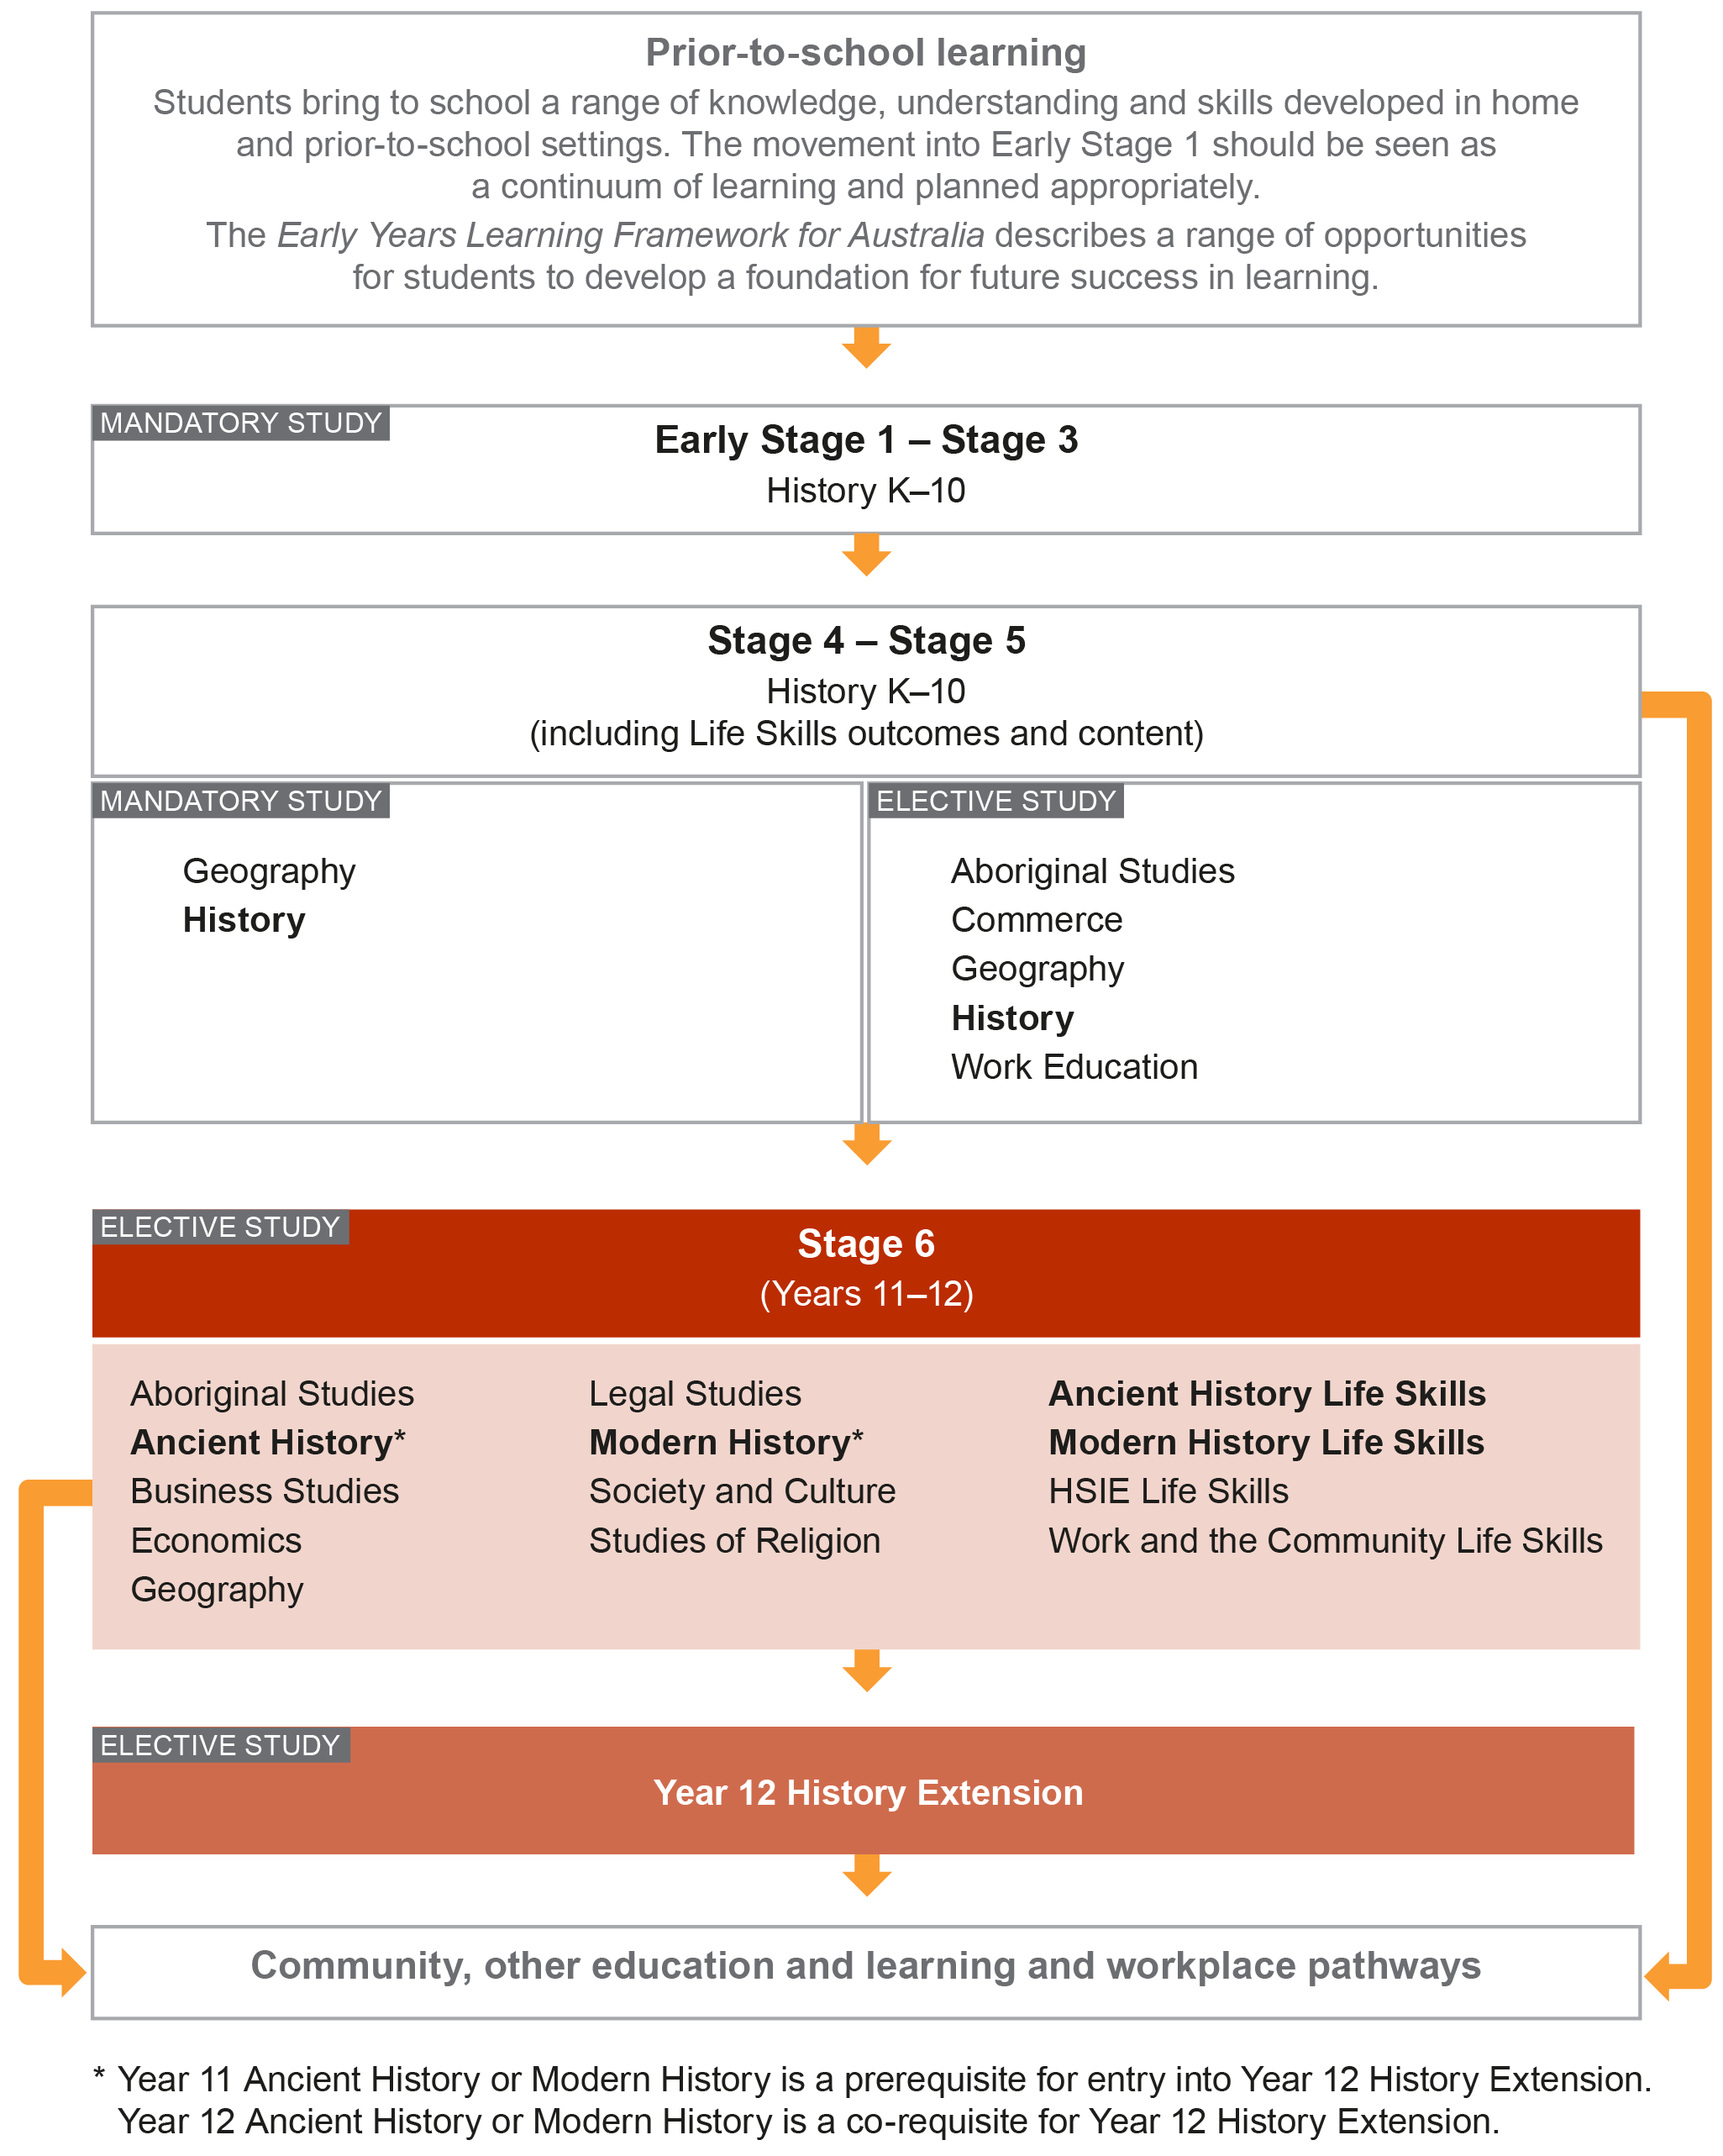

Aim
The Modern History Life Skills Stage 6 Syllabus aim is consistent with the Modern History Stage 6 Syllabus aim. The Modern History aim is provided below.

The study of Modern History in Stage 6 enables students to:
- develop knowledge and understanding of the modern world, the skills of critical analysis, and values and attitudes essential for an appreciation of the people, forces and ideas that have shaped the modern world
- develop a lifelong interest in the study of history
- prepare for active and informed citizenship in the contemporary world.

Objectives

Knowledge and Understanding
Students:
- develop knowledge and understanding of a range of features, people, ideas, movements, events and developments of the modern world in their historical context
- develop an understanding of continuity and change over time.

Skills
Students:
- undertake the process of historical inquiry
- use historical concepts and skills to examine the modern past
- communicate their understanding of history, sources and evidence, and historical interpretations.

Values and Attitudes
Students:
- appreciate the influence of the past on the present and the future
- value the contribution of the study of Modern History to lifelong learning, and active and informed citizenship.

Outcomes

Table of Objectives and Outcomes – Continuum of Learning
For students undertaking Modern History Life Skills:
- students are not required to complete all Life Skills outcomes
- specific Life Skills outcomes should be selected on the basis that they meet the learning needs, strengths, goals and interests of each student
- outcomes may be demonstrated independently or with support.

Knowledge and Understanding
Objectives
Students:
- develop knowledge and understanding of a range of features, people, ideas, movements, events and developments of the modern world in their historical context
- develop an understanding of continuity and change over time.
Life Skills outcomes
A student:
MHLS6-1 engages with personal connections to history
MHLS6-2 engages with the concepts of time and chronology
MHLS6-3 explores continuity and change in the modern world
MHLS6-4 explores events and developments of the modern world
MHLS6-5 investigates features, people, ideas and movements in the modern world
MHLS6-6 engages with perspectives of the past
MHLS6-7 investigates a range of historical aspects in understanding the past

Skills
Objectives
Students:
- undertake the process of historical inquiry
- use historical concepts and skills to examine the modern past
- communicate their understanding of history, sources and evidence, and historical interpretations.
Life Skills outcomes
A student:
MHLS6-8 engages with a variety of sources to investigate the past
MHLS6-9 engages with differing interpretations and representations of the past
MHLS6-10 investigates the past using a variety of strategies to locate, select and organise information
MHLS6-11 communicates information about the past using historical terms and concepts
MHLS6-12 engages with the investigation of Modern History

Modern History Life Skills and Related Modern History Stage 6 Syllabus Outcomes
The Modern History Life Skills Stage 6 outcomes align with the outcomes of the Modern History Stage 6 Syllabus to provide opportunities for integrated delivery.

Knowledge and Understanding
Objectives
Students:
- develop knowledge and understanding of a range of features, people, ideas, movements, events and developments of the modern world in their historical context
- develop an understanding of continuity and change over time
Life Skills outcomes  A student: | Related Modern History outcomes  A student:
MHLS6-1 engages with personal connections to history | NA
MHLS6-2 engages with the concepts of time and chronology | NA
MHLS6-3 explores continuity and change in the modern world | MH11-1 describes the nature of continuity and change in the modern world  MH12-1 accounts for the nature of continuity and change in the modern world
MHLS6-4 explores events and developments of the modern world | MH11-2 proposes ideas about the varying causes and effects of events and developments  MH12-2 proposes arguments about the varying causes and effects of events and developments
MHLS6-5 investigates features, people, ideas and movements in the modern world | MH11-3 analyses the role of historical features, individuals, groups and ideas in shaping the past  MH12-3 evaluates the role of historical features, individuals, groups and ideas in shaping the past
MHLS6-6 engages with perspectives of the past | MH11-4 accounts for the different perspectives of individuals and groups  MH12-4 analyses the different perspectives of individuals and groups in their historical context
MHLS6-7 investigates a range of historical aspects in understanding the past | MH11-5 examines the significance of historical features, people, ideas, movements, events and developments of the modern world  MH12-5 assesses the significance of historical features, people, ideas, movements, events and developments of the modern world

Skills
Objectives
Students:
- undertake the process of historical inquiry
- use historical concepts and skills to examine the modern past
- communicate their understanding of history, sources and evidence, and historical interpretations
Life Skills outcomes  A student: | Related Modern History outcomes  A student:
MHLS6-8 engages with a variety of sources to investigate the past | MH11-6 analyses and interprets different types of sources for evidence to support an historical account or argument  MH12-6 analyses and interprets different types of sources for evidence to support an historical account or argument
MHLS6-9 engages with differing interpretations and representations of the past | MH11-7 discusses and evaluates differing interpretations and representations of the past  MH12-7 discusses and evaluates differing interpretations and representations of the past
MHLS6-10 investigates the past using a variety of strategies to locate, select and organise information | MH11-8 plans and conducts historical investigations and presents reasoned conclusions, using relevant evidence from a range of sources  MH12-8 plans and conducts historical investigations and presents reasoned conclusions, using relevant evidence from a range of sources
MHLS6-11 communicates information about the past using historical terms and concepts | MH11-9 communicates historical understanding, using historical knowledge, concepts and terms, in appropriate and well-structured forms  MH12-9 communicates historical understanding, using historical knowledge, concepts and terms, in appropriate and well-structured forms
MHLS6-12 engages with the investigation of Modern History | MH11-10 discusses contemporary methods and issues involved in the investigation of Modern History

Course Structure
Year 11  (120 hours)  Year 12  (120 hours) | Modern History Life Skills
Investigating Modern History
- The Nature of Modern History
- Case Studies
 | Historical Investigation
 | The Shaping of the Modern World
 | Power and Authority in the Modern World 1919–1946
 | National Studies
 | Peace and Conflict
 | Change in the Modern World

For Modern History Life Skills:
- Students are not required to address or achieve all of the Modern History Life Skills outcomes.
- Students are not required to complete all of the content to demonstrate achievement of an outcome.
- Outcomes and content should be selected to meet the particular needs of individual students.
- The case studies, topics and content focus provide possible frameworks for addressing the Modern History Life Skills outcomes and content, and are suggestions only. Teachers have the flexibility to develop case studies and topics that will meet the needs, strengths, goals, interests and prior learning of their students.
- Examples provided under the content points are suggestions only. Teachers may use the examples provided or develop other examples to meet the particular needs of individual students.
- Students may explore one case study/topic, part of a case study/topic or elements of the content as appropriate.
- The Historical concepts and skills content should be integrated throughout the course. These skills provide opportunities to engage with the concepts of causation, continuity and change, perspectives, significance and contestability. The case studies and topics provide the contexts through which concepts and skills should be developed.

Assessment and Reporting
A student undertaking Modern History Life Skills will study selected outcomes and content, as identified through the collaborative curriculum planning process. The syllabus outcomes and content form the basis of learning opportunities for students.

Assessment should provide opportunities for students to demonstrate achievement in relation to the outcomes and to apply their knowledge, understanding and skills to a range of situations or environments, including the school and the wider community.

Evidence of student achievement of Life Skills outcomes can be based on a range of assessment for learning opportunities. There is no requirement for formal assessment of Life Skills outcomes. Schools are not required to report achievement using the Preliminary Common Grade Scale or assessment marks.

This information should be read in conjunction with requirements on the Assessment Certification Examination (ACE) website.

Additional advice is available in the Principles of Assessment for Stage 6.

Content
Content in Stage 6 Life Skills syllabuses is suggested. Content describes the intended learning for students as they work towards achieving one or more syllabus outcomes. It provides the foundations for students to progress to the next stage of schooling or post-school opportunities.

Teachers will make decisions about the choice of outcomes and selection of content regarding the sequence, emphasis and any adjustments required based on the needs, strengths, goals, interests and prior learning of students.

Organisation of Content
The following diagram provides an illustrative representation of elements of the course and their relationship.

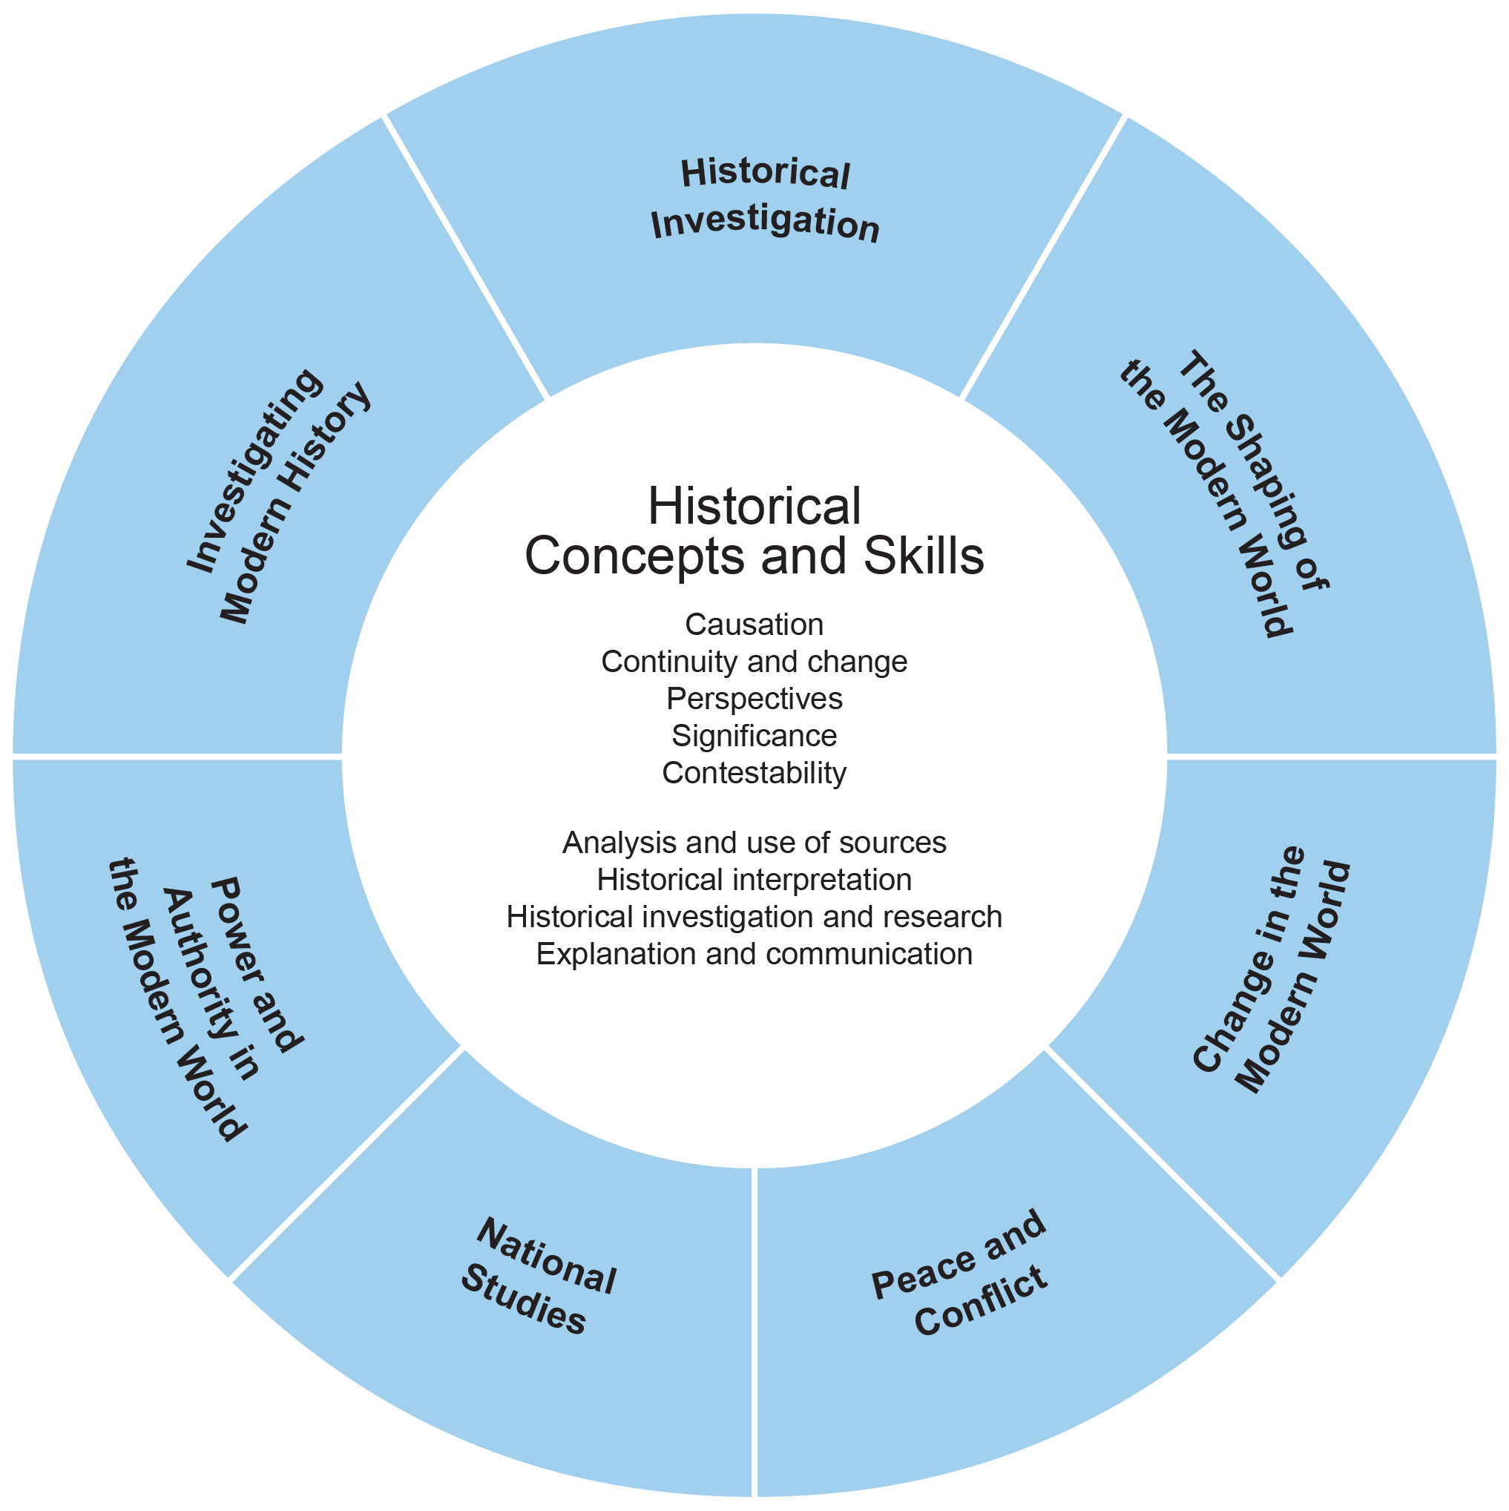

Learning Across the Curriculum
Learning across the curriculum content, including the cross-curriculum priorities and general capabilities, assists students to achieve the broad learning outcomes defined in the NESA Statement of Equity Principles, the Melbourne Declaration on Educational Goals for Young Australians (December 2008) and in the Australian Government’s Core Skills for Work Developmental Framework (2013).

Cross-curriculum priorities enable students to develop understanding about and address the contemporary issues they face.

The cross-curriculum priorities are:
- Aboriginal and Torres Strait Islander histories and cultures
- Asia and Australia’s engagement with Asia
- Sustainability

General capabilities encompass the knowledge, skills, attitudes and behaviours to assist students to live and work successfully in the 21st century.

The general capabilities are:
- Critical and creative thinking
- Ethical understanding
- Information and communication technology capability
- Intercultural understanding
- Literacy
- Numeracy
- Personal and social capability

NESA syllabuses include other areas identified as important learning for all students:
- Civics and citizenship
- Difference and diversity
- Work and enterprise

Learning across the curriculum content is incorporated, and identified by icons, in the content of the Modern History Life Skills Stage 6 Syllabus in the following ways.

Aboriginal and Torres Strait Islander Histories and Cultures
The study of Modern History includes the investigation of individuals and groups that have influenced movements for change, the progress towards recognition and equality for Aboriginal and Torres Strait Islander Peoples, and the focus of continued efforts. In the study of Modern History this understanding may be deepened through the study of other Indigenous peoples and through exploration of their interaction with others.
When planning and programming content relating to Aboriginal and Torres Strait Islander histories and cultures teachers are encouraged to:
- involve local Aboriginal communities and/or appropriate knowledge holders in determining suitable resources, or to use Aboriginal or Torres Strait Islander authored or endorsed publications
- read the Principles and Protocols relating to teaching and learning about Aboriginal and Torres Strait Islander histories and cultures and the involvement of local Aboriginal communities.

Asia and Australia’s Engagement with Asia
In Modern History, the study of Asia and Australia’s engagement with Asia can include the paths of development taken by Asian nations (and how they differ from the European experience), the distinctive and changing character of Asia, the growing influence of Asia in the world and how Australia’s engagement with Asia in the modern period has changed over time – culturally, economically and politically.

Sustainability
In Modern History, sustainability provides opportunities to study the effects of developments such as the Industrial Revolution on the environment, the anti-nuclear movement and movements for environmental sustainability in the modern period.

Critical and Creative Thinking
Critical and creative thinking is integral to the historical inquiry process. There are opportunities for students to consider the implications of any missing or questionable information in their investigation of historical topics. The process of historical inquiry provides opportunities for students to pose questions, select and cross-reference sources, and develop interpretations based on an assessment of the evidence available. Students can consider and reflect on alternative interpretations of the past.

Ethical Understanding
Ethical understanding provides opportunities for students to explore and understand the diverse perspectives and circumstances that shaped the actions and possible motivations of people in the past compared with those of today. In Modern History, students have opportunities both independently and collaboratively to explore the values, beliefs and principles that were the basis for the judgements and actions of people in the past.

Information and Communication Technology Capability
Information and communication technology (ICT) capability is important in the study of Modern History, particularly in relation to historical investigation, analysis and communication. In Modern History, students use digital tools and strategies to locate, access and process information. They use ICT skills and understanding to engage with evidence and to communicate historical information. Students have opportunities to evaluate websites and online communication, and the interpretations and representations of the past they convey. This includes how and why such sites are constructed (for example, for ideological or political purposes, commemoration, preservation, education and scholarship), the audiences they serve, and the techniques they use. They can develop an understanding of the issues involved in the use of ICT when practising ethical scholarship as part of the historical inquiry process.

Intercultural Understanding
Intercultural understanding is an important part of historical learning in Modern History. Students explore the different beliefs and values of a range of cultural groups and can develop an appreciation of diversity in the modern period. They have opportunities to develop an understanding of the nature, causes and consequences of conflict, dispossession and interdependence. Students also have opportunities to develop an understanding of different contemporary perspectives, the historical contexts for those perspectives, their historical influence on the relationships between different groups within society, and how they contribute to individual and group actions in the contemporary world.

Literacy
Literacy is of fundamental importance in the study of Modern History. Students access historical content through a variety of print, oral, visual, spatial, aural and electronic forms, including letters, speeches, biographies, photographs, films, artefacts, sites and archived material. They learn about interpreting and extrapolating meaning from a variety of sources to identify evidence. They reflect on texts for authority, reliability, relevance and accuracy. Students have opportunities to create a wide range of texts to communicate, explore, discuss, explain and express their thoughts and ideas, supported by evidence. They are provided with opportunities to learn to monitor their own language for accuracy in the use of historical terms, clarity of ideas and explanations, conciseness of expression, and to articulate a position on an historical problem or issue.

Numeracy
Numeracy is valuable in the historical inquiry process, such as recognising patterns and relationships chronologically and spatially through the use of timelines and maps. Students have opportunities to investigate data, some of which is numerical in nature. They have opportunities to develop numeracy capability when they analyse and interpret statistical information to draw conclusions, for example in relation to change over time.

Personal and Social Capability
Personal and social capability is developed in Modern History by students enhancing their communication skills and participating in teamwork. Students have opportunities to work both collaboratively in teams and also independently as part of their learning, and research, in Modern History. Students can develop research and presentation skills to express and justify their views effectively to others. Through the study of individuals and groups in the past, students have opportunities to develop their ability to appreciate the perspectives and experiences of others. Students can develop social awareness through the study of relationships between individuals and groups in the modern world.

Civics and Citizenship
In Modern History, students have the opportunity to study the development of political institutions across the world as part of their learning and research. They can learn about contested power and authority within and between nations, and develop increasing social and political awareness. This promotes students’ participation in Australia’s democracy by equipping them with the knowledge, understanding, skills, values and dispositions of active and informed citizenship.

Difference and Diversity
Modern History is well placed to develop students' knowledge and understanding about the difference of various groups in the modern world. Students can learn to identify and appreciate the varying perspectives of individuals and groups over time and attempt to understand the actions, values, attitudes and motives of people from the past. This focus on difference and diversity provides students with the opportunity to explore similarities and differences between the past and the contemporary world. Such an approach enables students to investigate the circumstances of those whom society has marginalised because of their beliefs, gender, race and socioeconomic status.

Work and Enterprise
In Modern History, there are opportunities to investigate living and working conditions in the past and how people’s experiences were shaped by changing social, economic and technological developments. Students are provided with opportunities to learn about earlier generations' struggles for rights and freedoms to understand how their own rights and responsibilities in the contemporary workplace have been achieved.

Modern History Life Skills Course Content

Course Structure
Year 11  (120 hours)  Year 12  (120 hours) | Modern History Life Skills
Investigating Modern History
- The Nature of Modern History
- Case Studies
 | Historical Investigation
 | The Shaping of the Modern World
 | Power and Authority in the Modern World
 | National Studies
 | Peace and Conflict
 | Change in the Modern World

For Modern History Life Skills:
- Students are not required to address or achieve all of the Modern History Life Skills outcomes.
- Students are not required to complete all of the content to demonstrate achievement of an outcome.
- Outcomes and content should be selected to meet the particular needs of individual students.
- The case studies, topics and content focus provide possible frameworks for addressing the Modern History Life Skills outcomes and content, and are suggestions only. Teachers have the flexibility to develop case studies and topics that will meet the needs, strengths, goals. interests and prior learning of their students.
- Examples provided under the content points are suggestions only. Teachers may use the examples provided or develop other examples to meet the particular needs of individual students.
- Students may explore one case study/topic, part of a case study/topic or elements of the content as appropriate.
- The Historical concepts and skills content should be integrated throughout the course. These skills provide opportunities to engage with the concepts of causation, continuity and change, perspectives, significance and contestability. The case studies and topics provide the contexts through which concepts and skills should be developed.

Historical Concepts and Skills
The following skills should be integrated with the content of the course. These skills provide opportunities to engage with the concepts of causation, continuity and change, perspectives, significance and contestability.

Analysis and use of sources

Outcomes
A student:
- engages with a variety of sources to investigate the past MHLS6-8

Content
Students:
- recognise a variety of historical sources
- identify the origin and purpose of historical sources
- identify different types of sources
- identify relevant information from a range of sources
- use sources to locate, select and use information
- explore the usefulness of sources
- demonstrate an understanding of historical inquiry

Historical interpretation

Outcomes
A student:
- engages with differing interpretations and representations of the past MHLS6-9

Content
Students:
- recognise various historical ideas and representations
- identify historical ideas and representations
- describe different historical ideas and representations
- compare different historical ideas and representations
- explore how different opinions in history can shape understanding

Historical investigation and research

Outcomes
A student:
- investigates the past using a variety of strategies to locate, select and organise information MHLS6-10
- engages with the investigation of modern history MHLS6-12

Content
Students:
- explore a range of archaeological and written sources
- locate relevant information about the past
- pose questions about the past
- engage with relevant sources to investigate questions
- engage with a range of written and non-written sources to locate, select and organise information
- engage with artefacts, sites and sources
- explore conservation and preservation of artefacts, sites and sources
- explore perspectives of individuals and groups
- recognise issues in investigating the past

Explanation and communication

Outcomes
A student:
- communicates information about the past using historical terms and concepts MHLS6-11

Content
Students:
- recognise where information has come from
- use historical terms and concepts appropriately
- develop texts about the past
- demonstrate understanding of time and chronology
- select and use a range of methods to communicate about the past
- demonstrate an understanding of the nature of history
- demonstrates an understanding of historical features, people, ideas, movements, events and developments

Investigating Modern History – The Nature of Modern History

Outcomes
A student:
- engages with personal connections to history MHLS6-1
- engages with the concepts of time and chronology MHLS6-2
- engages with a variety of sources to investigate the past MHLS6-8
- engages with differing interpretations and representations of the past MHLS6-9
- communicates information about the past using historical terms and concepts MHLS6-11
- engages with the investigation of modern history MHLS6-12

Related Modern History outcomes: MH11-6, MH11-7, MH11-9, MH11-10, MH12-6, MH12-7,
MH12-9

Content Focus
Students engage with the nature of modern history through an investigation of relevant methods and issues. The Historical concepts and skills content should be integrated as appropriate. These skills provide opportunities to engage with the concepts of causation, continuity and change, perspectives, significance and contestability.

The following options are suggestions only. Teachers may develop their own options. Students may explore one option, part of an option or elements of the content as appropriate.

- The Investigation of Historic Sites and Sources
- The Contestability of the Past
- The Construction of Modern Histories
- History and Memory
- The Representation and Commemoration of the Past.

1. The Investigation of Historic Sites and Sources

Content Focus
Students investigate the significance of historic sites and sources, including the contribution of science, in developing our understanding of the past. The Historical concepts and skills content should be integrated as appropriate. These skills provide opportunities to engage with the concepts of causation, continuity and change, perspectives, significance and contestability.

Content
Students:
- recognise the passage of time in their everyday life and explore the language of time
- recognise different types of sources, for example primary and secondary sources, print and digital sources
- recognise that sources can be used to answer questions about the past, for example:
- how people lived
- why people may have lived that way
- how and why life circumstances changed
- identify how time is measured, for example centuries
- identify some of the ways historians and archaeologists record history, for example written accounts, photographs, drawings, details of located artefacts
- identify places where historians can find sources to investigate the past
- use the language of time in a range of contexts
- identify some of the ways their family history has been recorded
- locate, select and organise a range of sources that are records of their personal history, for example photographs, personal objects, videos, reports, awards
- use sources to explore the history of a familiar site, for example school, local building
- use sources to gain an understanding of events, personalities or places in the past from their own lives and families, in the local community and beyond
- use chronology to order events, personalities, changes and places from the past, for example construct and present a timeline of significant events in the history of their family
- engage with sources relating, for example:
- to everyday life in the past
- to past traditions, practices, customs and religious beliefs in their own family, in the local community and beyond, eg buildings, texts, images, music, technology
- explore how historic sites and museums can provide historians with an understanding of events, people and developments in the past
- explore the role of changing technologies, including scientific techniques, in investigating and reconstructing the past

2. The Contestability of the Past

Content Focus
Students investigate the problems relating to the contestability of the past, focusing on sources available to historians. The Historical concepts and skills content should be integrated as appropriate. These skills provide opportunities to engage with the concepts of causation, continuity and change, perspectives, significance and contestability.

Content
Students:
- recognise how historians use sources to gather information about the past
- recognise the process historians use to decide if a source is reliable
- recognise how historians use historical context to understand sources
- identify influences on interpretation
- identify the type and origin of artefacts
- explore the role of sources and evidence in arriving at the ‘truth’ about the past
- explore the difference between fact and opinion
- recognise the reliability of writers who did not witness the events they describe
- identify sources that are deemed to be forgeries over time
- recognise the motivations of the perpetrators of fakes and forgeries and explore the significance of this evidence for learning about the past
- explore challenges in the process of undertaking an historical investigation, for example:
- supporting and contradictory evidence
- validity and reliability of sources
- problems of authenticity
- selectivity of evidence
- accuracy in recording findings

3. The Construction of Modern Histories

Content Focus
Students investigate the methods and issues associated with constructing accounts about the past. The Historical concepts and skills content should be integrated as appropriate. These skills provide opportunities to engage with the concepts of causation, continuity and change, perspectives, significance and contestability.

Content
Students:
- recognise that people can have differing experiences of the same period in time
- recognise that people have different perspectives about the past
- explore the different ways history can be made, eg narrative history, biography, oral histories, anecdotes, news reports, artefacts and formal historical publications
- compare the accounts of local history given by a variety of people
- engage with a range of historical texts and sources to explore a particular person, event or place from the past in their own family, in the local community and beyond
- identify differing experiences, interpretations, and perspectives of the past in a range of historical texts and sources
- compare differing experiences, interpretations, and perspectives of the past
- identify the use of evidence in the construction of histories
- describe how historians decide what is important in the making of modern histories
- communicate ideas about a person, event or place from the past using different perspectives, for example write a diary entry from the perspective of a soldier and a civilian during World War I

4. History and Memory

Content Focus
Students investigate the methods and issues associated with the expression of memories about the past. The Historical concepts and skills content should be integrated as appropriate. These skills provide opportunities to engage with the concepts of causation, continuity and change, perspectives, significance and contestability.

Content
Students:
- identify methods used to remember the past
- recognise the way stories are used to create and remember the past
- recognise problems with using oral stories to remember the past
- recognise that people may have different memories of the past
- engage with historical sources that tell us about the past in their own lives and families, in the local community and beyond
- explore the use of evidence to construct and remember the past

5. The Representation and Commemoration of the Past

Content Focus
Students investigate the ways in which the past is represented and commemorated. The Historical concepts and skills content should be integrated as appropriate. These skills provide opportunities to engage with the concepts of causation, continuity and change, perspectives, significance and contestability.

Content
Students:
- recognise the ceremonies that individuals and groups carry out to remember the past
- identify the places where history can be displayed
- explore how history is displayed within the community in order to remember the past
- recognise different interpretations and/or representations of the past, for example art, memorials,
museums, media, film, documentaries, multimedia, interactive media
- use sources to identify differing interpretations and/or representations of the past from their own lives and families, in the local community and beyond
- compare differing interpretations and/or representations of the past
- explore the various ways a person, society or event from the past has been represented over time
- recognise the reasons for the differing interpretations and/or representations
- recognise the importance of Aboriginal and Torres Strait Islander histories and cultures, including Indigenous cultural and intellectual property rights
- engage in ceremonies that commemorate the past
- communicate their own point of view in relation to the significance of commemorations of the past

Investigating Modern History – Case Studies

Outcomes
A student:
- engages with personal connections to history MHLS6-1
- engages with the concepts of time and chronology MHLS6-2
- explores continuity and change in the modern world MHLS6-3
- explores events and developments of the modern world MHLS6-4
- investigates features, people, ideas and movements in the modern world MHLS6-5
- engages with perspectives of the past MHLS6-6
- investigates a range of historical aspects in understanding the past MHLS6-7
- engages with a variety of sources to investigate the past MHLS6-8
- engages with differing interpretations and representations of the past MHLS6-9
- communicates information about the past using historical terms and concepts MHLS6-11

Related Modern History outcomes: MH11-1, MH11-2, MH11-3, MH11-4, MH11-5, MH11-6,
MH11-7, MH11-9, MH12-3, MH12-4, MH12-5, MH12-6, MH12-7, MH12-9

Content Focus
Students investigate aspects of the history of the modern world using a range of sources. The Historical concepts and skills content should be integrated as appropriate. These skills provide opportunities to engage with the concepts of causation, continuity and change, perspectives, significance and contestability.

The case studies for students undertaking a Life Skills pattern of study should develop students’ historical knowledge, skills and understanding through the exploration of historical sources and content. Teachers may develop their own case studies focusing on their students’ own lives and families, the local community and/or beyond, as relevant and appropriate for students. The following aspects may be included in the case study:

- methods of investigating the modern past as relevant
- key historical features and issues
- the role of individuals and/or groups in their historical context
- key events and/or developments, their causes and how they shaped the past
- the impact of the events on the history of an individual nation, region and/or the world as a whole.

The following case studies are suggestions only. Teachers may choose to develop ideas and concepts from these case studies to address Life Skills outcomes if appropriate. Students may explore one case study, part of a case study or elements of the content as appropriate.

Examples of case studies from Australia, Europe, North America | Examples of case studies from Asia, the Pacific, Africa, the Middle East, Central/South America
- Australia and the Rise of Communism  - Making Change: Day of Mourning to Mabo  - The Changing Nature of Anglo-Irish Relations  - The Decline and Fall of the Romanov Dynasty  - The Trans-Atlantic Slave Trade  - The American Civil War  - The Rise of the Environmental Movement  - Women’s Movements | - The Boxer Rebellion in China  - The British in India and Burma  - The Meiji Restoration  - Tibet in the Modern World  - Making Contact with the Pacific  - The Making of Modern South Africa  - The Origins of the Arab–Israeli conflict  - The Cuban Revolution

Content
Students:
- explore methods of investigating the modern past in their own lives, in the local community and beyond, for example:
- artefacts, sites and sources
- conservation and preservation of artefacts, sites and sources
- interpretation, perspective and representation
- explore key historical features and issues in their own lives, in the local community and beyond, for example:
- everyday life
- culture
- environment and the need to protect and conserve the environment
- legislation and international cooperation to protect the environment
- society and politics
- economics
- efforts of Aboriginal and Torres Strait Islander Peoples to achieve positive change
- religion
- rights and freedoms
- women’s rights, movements and discrimination
- civil rights
- the reasons and need for exploration and problems faced by early explorers
- colonisation and imperialism
- independence and occupation
- ways in which people and groups fought for liberation and/or independence
- enslaved people and convicts
- revolution
- democracy and citizenship
- migration
- explore the role of individuals and groups in their historical context in their own lives, in the local community and beyond, for example:
- positive or negative relations between people from different cultures
- the achievements of Aboriginal and Torres Strait Islander Peoples
- environmental protection agencies, societies, groups or campaigns
- significant personalities, events and achievements of the women’s movements in the fight for women’s rights
- exploration and settlement
- significant explorers and their discoveries
- explore key events, their causes and how they shaped the past in their own lives, in the local community and beyond, for example:
- the significance of wars, rights and society
- countries that fought for independence, and its impact
- explore the impact of the events on the history of an individual nation, region and/or the world as a whole, for example:
- movements towards reconciliation in Australia
- post war developments, improvements and changes in society
- effect of colonisation and contact on Indigenous groups

Historical Investigation

Outcomes
A student:
- engages with personal connections to history MHLS6-1
- engages with the concepts of time and chronology MHLS6-2
- explores continuity and change in the modern world MHLS6-3
- explores events and developments of the modern world MHLS6-4
- investigates features, people, ideas and movements in the modern world MHLS6-5
- engages with perspectives of the past MHLS6-6
- investigates a range of historical aspects in understanding the past MHLS6-7
- engages with a variety of sources to investigate the past MHLS6-8
- engages with differing interpretations and representations of the past MHLS6-9
- investigates the past using a variety of strategies to locate, select and organise information MHLS6-10
- communicates information about the past using historical terms and concepts MHLS6-11
- engages with the investigation of modern history MHLS6-12

Related Modern History outcomes: MH11-1, MH11-2, MH11-3, MH11-4, MH11-5, MH11-6,
MH11-7, MH11-8, MH11-9, MH11-10, MH12-3, MH12-4, MH12-5, MH12-6, MH12-7, MH12-8,
MH12-9

Content Focus
Students engage with an historical investigation, designed to provide opportunities for students to further develop relevant investigative, research and presentation skills. The Historical concepts and skills content should be integrated as appropriate. These skills provide opportunities to engage with the concepts of causation, continuity and change, perspectives, significance and contestability.

The historical investigation may focus on students’ own lives and families, the local community and/or beyond, as relevant and appropriate. The outcomes addressed in the investigation build on the Years 7–10 History Life Skills outcomes. Students should explore elements of the content as appropriate.

Possible historical investigations could include:
- aspects of society as revealed through sources
- the impact of an historical event on people at the time
- the significance of an historical development
- tracing the development of an aspect of the past over time through a thematic approach
- the contribution of an historical site to our understanding of the past
- constructions of the modern world
- an interpretation or representation of an individual, group or event.

Content
The process of investigation could involve:
- planning an historical inquiry
- investigating the past using historical skills
- exploring a range of archaeological and written sources
- identifying historical questions
- posing questions about the past
- developing a personal connection to historical investigations
- engaging with relevant sources to investigate questions
- identifying what sources can reveal about the past
- using a range of sources to locate, select and organise information
- using a range of sources to develop historical knowledge and understanding
- describing historical issues
- using historical terms appropriately
- recognising the significance of events and people in the past
- engaging with chronology and concepts, for example developing a timeline of an historical event, personality, period or concept
- recognising different historical perspectives of people, events and issues
- using sources to identify different perspectives about the past
- examining sources for their usefulness
- using sources to develop opinions about history and historical issues
- developing texts to communicate about the past
- presenting and communicating information using a range of oral, written and/or multimedia forms, including ICT

The Shaping of the Modern World

Outcomes
A student:
- engages with personal connections to history MHLS6-1
- engages with the concepts of time and chronology MHLS6-2
- explores continuity and change in the modern world MHLS6-3
- explores events and developments of the modern world MHLS6-4
- investigates features, people, ideas and movements in the modern world MHLS6-5
- engages with perspectives of the past MHLS6-6
- investigates a range of historical aspects in understanding the past MHLS6-7
- engages with a variety of sources to investigate the past MHLS6-8
- engages with differing interpretations and representations of the past MHLS6-9
- investigates the past using a variety of strategies to locate, select and organise information MHLS6-10
- communicates information about the past using historical terms and concepts MHLS6-11

Related Modern History outcomes: MH11-1, MH11-2, MH11-3, MH11-4, MH11-5, MH11-6,
MH11-7, MH11-8, MH11-9, MH12-3, MH12-4, MH12-5, MH12-6, MH12-7, MH12-8,
MH12-9

Content Focus
Students investigate forces and ideas that shaped the modern world through a study of key events and developments and the meaning of modernity. The Historical concepts and skills content should be integrated as appropriate. These skills provide opportunities to engage with the concepts of causation, continuity and change, perspectives, significance and contestability.

The following topics are suggestions only. Teachers should develop ideas and concepts from these topics to address Life Skills outcomes if appropriate. Topics could focus on students’ own lives and families, the local community and/or beyond, as relevant and appropriate for students. Students may explore one topic, part of a topic or elements of the content as appropriate.

1. The Enlightenment
2. The French Revolution
3. The Age of Imperialism
4. The Industrial Age
5. World War I
6. The End of Empire.

Content
Students:
- explore the causes, developments and legacies that helped define the modern world in their own lives, in the local community and beyond, for example:
- developments and legacies
- origins of developments and legacies
- impact of developments and legacies on different groups
- overall impact of developments
- changes and impact of technology
- advances in medicine and communications
- scientific and industrial developments in weaponry
- manufacturing industries
- wars, revolutions, colonisation and key individuals and countries involved
- the significance and impact of wars, revolutions, colonisation and decolonisation
- changes that occurred during and since wars and revolutions eg change in society, agricultural production, transport, communication, living and working conditions, and urbanisation
- varying perspectives on developments and legacies
- interpretations and representations of developments and legacies
- similarities and differences between then and now

Power and Authority in the Modern World 1919–1946

Outcomes
A student:
- engages with personal connections to history MHLS6-1
- engages with the concepts of time and chronology MHLS6-2
- explores continuity and change in the modern world MHLS6-3
- explores events and developments of the modern world MHLS6-4
- investigates features, people, ideas and movements in the modern world MHLS6-5
- engages with perspectives of the past MHLS6-6
- investigates a range of historical aspects in understanding the past MHLS6-7
- engages with a variety of sources to investigate the past MHLS6-8
- engages with differing interpretations and representations of the past MHLS6-9
- investigates the past using a variety of strategies to locate, select and organise information MHLS6-10
- communicates information about the past using historical terms and concepts MHLS6-11

Related Modern History outcomes: MH11-1, MH11-2, MH11-3, MH11-4, MH11-5, MH11-6,
MH11-7, MH11-8, MH11-9, MH12-1, MH12-2, MH12-3, MH12-4, MH12-5, MH12-6, MH12-7, MH12-8, MH12-9

Content Focus
Through a focus on the nature of power and authority, students investigate the rise of movements, what drew people to these movements, the regimes that emerged and ongoing efforts to achieve collective security. The Historical concepts and skills content should be integrated as appropriate. These skills provide opportunities to engage with the concepts of causation, continuity and change, perspectives, significance and contestability.

Students should explore elements of the content as appropriate.

Content
Students:
- recognise personal experiences of power and authority, for example parents, teachers, doctors
- recognise power and authority in a society, for example rulers, kings and queens, government, police
- recognise the difference and similarities between power and authority
- identify examples of individuals and groups who use power and authority positively and negatively, for example the positive power and authority of teachers and police in contrast to the negative power of a bully or a criminal
- identify measures in society that limit the power and authority of particular groups, for example school rules, laws, political systems
- explore the difference between democracy and dictatorship
- explore examples of significant individuals in history who have used power and authority positively
- explore examples of significant individuals in history who have used power and authority negatively, for example Benito Mussolini, Adolf Hitler
- investigate a significant individual who has had power and authority in the modern world, and consider how they achieved their power and how they used their power and legacy, for example Adolf Hitler
- explore the rise of dictatorships, for example:
- the conditions that enabled dictators to rise to power
- the nature of dictatorships that emerged, eg in Russia, Italy and Japan
- the rise of regimes, their ideology, methods and impact, and the opposition to regimes
- the threats to democracy and the collapse of regimes
- explore peace treaties and their consequences
- explore international organisations and their search for peace and security

National Studies

Outcomes
A student:
- engages with personal connections to history MHLS6-1
- engages with the concepts of time and chronology MHLS6-2
- explores continuity and change in the modern world MHLS6-3
- explores events and developments of the modern world MHLS6-4
- investigates features, people, ideas and movements in the modern world MHLS6-5
- engages with perspectives of the past MHLS6-6
- investigates a range of historical aspects in understanding the past MHLS6-7
- engages with a variety of sources to investigate the past MHLS6-8
- engages with differing interpretations and representations of the past MHLS6-9
- investigates the past using a variety of strategies to locate, select and organise information MHLS6-10
- communicates information about the past using historical terms and concepts MHLS6-11

Related Modern History outcomes: MH11-1, MH11-2, MH11-3, MH11-4, MH11-5, MH11-6,
MH11-7, MH11-8, MH11-9, MH12-1, MH12-2, MH12-3, MH12-4, MH12-5, MH12-6, MH12-7, MH12-8, MH12-9

Content Focus
Students investigate key features, individuals, groups, events and developments that shaped the history of a selected nation. The Historical concepts and skills content should be integrated as appropriate. These skills provide opportunities to engage with the concepts of causation, continuity and change, perspectives, significance and contestability.

The following countries and periods are suggestions only. Students may explore one country and period, part of a country and period or elements of the content as appropriate.

- Australia 1918–1949
- China 1927–1949
- India 1942–1984
- Indonesia 1945–2005
- Japan 1904–1937
- Russia and the Soviet Union 1917–1941
- USA 1919–1941
- Iran 1945–1989.

Content
Students:
- explore factors contributing to the events
- investigate the main features of the events
- explore the impact of events on the history of local communities, the individual nation, region or world as a whole
- explore how features and issues of the period reflect continuity and change over time, for example:
  - geographical: borders, imperialism, alliances/conflicts with neighbours, preservation of significant places and sites
  - social and political: roles of leaders/significant people, political ideologies and political parties, nationalism, foreign policy, alliances, social classes, belief systems, multiculturalism and racism
  - economic: transport, trade, globalisation, growth/decline
  - religious: belief systems, sacred places and sites, practices
- investigate key features of a particular conflict during this period
- explore one or more significant individuals from the selected period in relation to their:
  - historical context
  - personal background and the values and attitudes that influenced their actions
  - rise to prominence
  - achievements and the significant events in their lives
  - contribution to the society and the time in which they lived, and the legacy of their contribution

Peace and Conflict

Outcomes
A student:
- engages with personal connections to history MHLS6-1
- engages with the concepts of time and chronology MHLS6-2
- explores continuity and change in the modern world MHLS6-3
- explores events and developments of the modern world MHLS6-4
- investigates features, people, ideas and movements in the modern world MHLS6-5
- engages with perspectives of the past MHLS6-6
- investigates a range of historical aspects in understanding the past MHLS6-7
- engages with a variety of sources to investigate the past MHLS6-8
- engages with differing interpretations and representations of the past MHLS6-9
- investigates the past using a variety of strategies to locate, select and organise information MHLS6-10
- communicates information about the past using historical terms and concepts MHLS6-11

Related Modern History outcomes: MH11-1, MH11-2, MH11-3, MH11-4, MH11-5, MH11-6,
MH11-7, MH11-8, MH11-9, MH12-1, MH12-2, MH12-3, MH12-4, MH12-5, MH12-6, MH12-7, MH12-8, MH12-9

Content Focus
Students investigate key features of the history of particular studies in peace and conflict. The Historical concepts and skills content should be integrated as appropriate. These skills provide opportunities to engage with the concepts of causation, continuity and change, perspectives, significance and contestability.

The following studies are suggestions only. Teachers may select their own historical study in peace and conflict. Students may explore one study, part of a study or elements of the content as appropriate.

- Conflict in Indochina 1954–1979
- Conflict in the Pacific 1937–1951
- Conflict in Europe 1935–1945
- The Cold War 1945–1991
- Conflict in the Gulf 1980–2011
- The Arab–Israeli Conflict 1948–1996.

Content
Students:
- recognise peace and conflict in their own lives, community and beyond
- identify groups involved in the conflict, for example countries, societies, religious groups
- locate on a map the main places where the conflict occurred
- explore the causes of conflict
- recognise international involvement in the conflict
- investigate major events and issues in the development of the conflict
- explore the role of key individuals, groups and/or organisations in the conflict
- explore each group’s response to the conflict
- investigate strategies, tactics and weaponry used by the countries involved in the conflict
- explore political systems that may have led to, or contributed to, the conflict
- explore the attempts at peacemaking and the success of these attempts
- investigate the impact of the conflict on the groups involved, an individual nation, region and/or the world as a whole

Change in the Modern World

Outcomes
A student:
- engages with personal connections to history MHLS6-1
- engages with the concepts of time and chronology MHLS6-2
- explores continuity and change in the modern world MHLS6-3
- explores events and developments of the modern world MHLS6-4
- investigates features, people, ideas and movements in the modern world MHLS6-5
- engages with perspectives of the past MHLS6-6
- investigates a range of historical aspects in understanding the past MHLS6-7
- engages with a variety of sources to investigate the past MHLS6-8
- engages with differing interpretations and representations of the past MHLS6-9
- investigates the past using a variety of strategies to locate, select and organise information MHLS6-10
- communicates information about the past using historical terms and concepts MHLS6-11

Related Modern History outcomes: MH11-1, MH11-2, MH11-3, MH11-4, MH11-5, MH11-6,
MH11-7, MH11-8, MH11-9, MH12-1, MH12-2, MH12-3, MH12-4, MH12-5, MH12-6, MH12-7, MH12-8, MH12-9

Content Focus
Students investigate key features of the history of particular studies in political and social change, and the role of individuals and groups. The Historical concepts and skills content should be integrated as appropriate. These skills provide opportunities to engage with the concepts of causation, continuity and change, perspectives, significance and contestability.

The following topics are suggestions only. Teachers may select their own historical topic from the students’ own lives and families, the local community and/or beyond, as relevant and appropriate for their students. Students may explore one topic, part of a topic or elements of the content as appropriate.

- Pro-democracy Movement in Burma 1945–2010
- The Cultural Revolution to Tiananmen Square 1966–1989
- Civil Rights in the USA 1945–1968
- The Changing World Order 1945–2011
- The Nuclear Age 1945–2011
- Apartheid in South Africa 1960–1994.

Content
Students:
- locate on a map the geographical region where the change took place
- identify countries and groups involved in the change
- identify factors contributing to the change
- explore main features of the change, for example political, social, economic, technological
- explore significant movements associated with the change, for example the civil rights movement, communism
- investigate issues involved in the change, for example rights and freedoms of individuals and groups, power and authority, democracy, oppression
- investigate the key personality involved in the change in relation to their:
  - historical context
  - personal background and the values and attitudes that influenced their actions
  - rise to prominence
  - significant events and achievements
  - contribution and legacy
- explore resistance from individuals and groups
- explore government and military involvement
- investigate consequences and impacts of the change
- explore contributions of the change to our world today, for example technological impacts, changes to government systems

Glossary
Glossary term | Definition
Aboriginal and Torres Strait Islander Peoples | Aboriginal Peoples are the first peoples of Australia and are represented by over 250 language groups each associated with a particular Country or territory. Torres Strait Islander Peoples whose island territories to the north east of Australia were annexed by Queensland in 1879 are also Indigenous Australians and are represented by five cultural groups.  An Aboriginal and/or Torres Strait Islander person is someone who:  - is of Aboriginal and/or Torres Strait Islander descent  - identifies as an Aboriginal person and/or Torres Strait Islander person, and  - is accepted as such by the Aboriginal and/or Torres Strait Islander community in which they live.
Aboriginal Cultural Protocols | Aboriginal Cultural Protocols describe appropriate ways of behaving, communicating and showing respect for diversity of histories and cultures. This involves appreciation of the knowledge, standing and status of people within the local Aboriginal community. Protocols inevitably vary between communities, and between people within a community. In establishing partnerships between Aboriginal communities and industries or professions, it is especially important that protocols are acknowledged and respected.
Ancient | As defined in the NSW Ancient History Stage 6 Syllabus, the Ancient period covers history from the development of early human communities to the end of late antiquity (around AD 650).
ANZAC | The word ANZAC refers to the Australian and New Zealand Army Corps (ANZAC) troops who first fought at Gallipoli in Turkey from April to December 1915.
causation | A process that includes a range of possible reasons for an historical event, situation or development.
chronology | A chronology places events and dates in order in time.
colonisation | In Modern History – a process by which a different system of government is established by one nation over another group of peoples. It involves the colonial power asserting and enforcing its sovereignty according to its own law, rather than by the laws of the colonised, and may involve dispossession of land.  In Ancient History – a process by which ancient societies establish settlements in other lands and establish trading connections.
concepts | The key ideas that shape the practice of the discipline of history, eg causation, continuity, change, and significance. They provide the scope for judgement, interpretation and argument and are the major means by which knowledge is constructed, analysed, questioned and represented.
contestability | Contestability involves examining how interpretations and representations of the past differ, for example, as a result of using differing evidence or resulting from different perspectives.
continuity and change | Aspects of the past that have remained the same over a period of time or have changed over time. Change can be understood as a ‘process’.
dispossession | The removal of people from their lands which had been occupied and cared for by their ancestors over thousands of years.
evidence | The information elicited and interpreted from a source that is used to support an historical argument or inform a specific historical inquiry.
heritage | Tangible or intangible aspects of the past that are valued by an individual, group, community or nation as a result of birth, inheritance or membership. It can also be applied to significant examples of the human or natural environment.
historical authentication | A process of verifying the origins of an artefact or object and establishing it as genuine.
historical inquiry | The process of developing knowledge and understanding by posing questions about the past, and applying skills associated with locating, analysing, evaluating and using sources as evidence to develop an informed argument or interpretation.
historiography | The study of how history is constructed. It involves the critical analysis and evaluation of historical methodologies and the way history has been written over time.
ideology | A framework of beliefs that guides actions, for example fascism and communism.
Indigenous cultural and intellectual property | Includes objects, sites, cultural knowledge, cultural expression and the arts, that have been transmitted or continue to be transmitted through generations as belonging to a particular Indigenous group or Indigenous people as a whole or their territory.
Indigenous peoples | This term is used when referring collectively to the first peoples of a land in international communities.
interpretation | A way of understanding and explaining what has happened in the past. The discipline of History acknowledges that there is often more than one view of what has happened in the past.
Modern | As defined in the NSW Modern History Stage 6 Syllabus, the period of time in the modern world generally between 1750 and the present.
perspective | A point of view from which historical events, problems and issues can be analysed, for example the perspective of an individual or group in the past. This may involve empathetic understanding – the capacity to enter into the world of the past from the point of view of a particular individual or group from that time, including an appreciation of the circumstances they faced, and the motivations, values and attitudes behind their actions.
reconstruction | A process of piecing together evidence from sources to develop an understanding or picture of the past. It may include the physical reconstruction of ancient sites.
reliability | Consideration of the context, purpose, origin and audience of a source, in order to determine how accurately an area of historical study is represented. A source is neither reliable or unreliable in and of itself. It can only be judged reliable or useful for the question that is asked. Reliability requires an understanding of perspective.
representation | A portrayal of the past that may reflect a popular view within society, past or present, or that may be constructed by historians.
significance | The importance attributed to a particular aspect of the past such as an individual or event. Significance involves an understanding of the various considerations which cause different groups at different times to judge aspects of the past more or less historically significant.
source | Any written or non-written materials that can be used to investigate the past. A source is used to elicit ‘evidence’ in order to answer a specific historical question, inform an historical inquiry, or to support or refute an interpretation.
terms | A word or phrase used to describe abstract aspects or features of the past, eg imperialism, democracy or republic; and more specific features such as trench warfare, or a dictator, gladiator or vizier.
terra nullius | A concept in international law meaning ‘a territory belonging to no-one’ or ‘over which no-one claims ownership’.

