History sample unit (integrated with Life Skills) | The Industrial Revolution  Depth Study 1: Making a better world? | Stage 5 | Duration: 7–8 weeks
History sample unit (integrated with Life Skills) |  | Stage 5 | Detail: 20 hours/24 lessons
History sample unit (integrated with Life Skills) | The overview may be programmed separately or integrated, where relevant, within this unit of work
Key inquiry questions |  | Skills
- What were the changing features of the movement of peoples from 1750 to 1918?  - How did new ideas and technological developments contribute to change in this period? |  | - Comprehension: chronology, terms and concepts  - Analysis and use of sources  - Perspectives and interpretations  - Empathetic understanding  - Research  - Explanation and communication

Outcomes | Historical concepts
A student:  - explains and assesses the historical forces and factors that shaped the modern world and Australia HT5-1  - sequences and explains the significant patterns of continuity and change in the development of the modern world and Australia HT5-2  - explains and analyses the causes and effects of events and developments in the modern world and Australia HT5-4  - uses relevant evidence from sources to support historical narratives, explanations and analyses of the modern world and Australia HT5-6  - applies a range of relevant historical terms and concepts when communicating an understanding of the past HT5-9  - selects and uses appropriate oral, written, visual and digital forms to communicate effectively about the past for different audiences HT5-10 | The following historical concepts are integrated into the lesson sequences:  Continuity and change: changes and continuities during the Industrial Revolution  Cause and effect: what were the causes of the Industrial Revolution and its overall effects?  Perspectives: different points of view about the Industrial Revolution held by people from the past and today  Empathetic understanding: why people from the era of the Industrial Revolution lived, thought and behaved as they did  Significance: the significance/importance of the Industrial Revolution

Related Life Skills outcomes and content
A student:
- investigates how people lived in various societies from the past HTLS-3
- explores the features of a particular society or time HTLS-4
- explores the significance of changes and developments in the past HTLS-6
- uses sources to understand the past HTLS-8
- uses historical terms to describe the past HTLS-11
- investigates the past using historical skills HTLS-12
- selects and uses a variety of strategies to organise and communicate information about the past HTLS-13
Technological advances arising from the Industrial Revolution
Students:
- explore how the Industrial Revolution affected the everyday life of people during that time, eg growth of towns and cities, development of transport systems, working conditions in factories, changed social conditions
- recognise one or more technological inventions that occurred during the Industrial Revolution, eg the steam engine, sewing machine, telephone, aeroplane
- investigate one or more technological inventions from the Industrial Revolution and the impact this has had on the lives of ordinary people, using ICT and other sources as appropriate
- recognise the ways in which one or more technological innovations has improved our everyday life
- engage with one or more technological innovations to perform a task
- recognise different perspectives of groups of people towards the Industrial Revolution, eg workers and factory owners

Content | Teaching, learning and assessment
The technological innovations that led to the Industrial Revolution, and other conditions that influenced the industrialisation of Britain (agricultural revolution, access to raw materials, wealthy middle class, cheap labour, transport system and expanding empire) and of Australia (ACDSEH017)  Outline the main reasons why the Industrial Revolution began in Britain  Describe the key features of the agricultural revolution in Britain, including the emergence of a cheap labour force, and describe the changes to the way of life of men and women who moved from the country to towns  Locate the growth and extent of the British Empire from 1750–1900 and identify the raw materials Britain obtained from its empire, for example sugar from Jamaica, wool from Australia, and cotton and tea from India  Identify key inventors and their inventions and discuss how some of these inventions affected transport and manufacturing in this period  Explain how industrialisation contributed to the development of Britain and Australia in this period  The population movements and changing settlement patterns during this period (ACDSEH080)  Outline and explain population movements in Britain, for example movement from country villages to towns and cities, and emigration to other countries  The experiences of men, women and children during the Industrial Revolution, and their changing way of life (ACDSEH081)  Describe the changes to the way of life of men and women who moved from the country to towns and cities  Use a variety of sources to investigate working conditions in factories, mines and other occupations, with particular emphasis on child labour  The short and long-term impacts of the Industrial Revolution, including global changes in landscapes, transport and communication (ACDSEH082)  Discuss positive and negative consequences of the Industrial Revolution, for example the growth of cities and pollution and the development of trade unions  Assess the short-term and long-term impacts of the Industrial Revolution, including global changes in landscapes, transport and communication | Students:  - Conduct individual online research on why the Industrial Revolution began in Britain. The following is a comprehensive teacher resource: www.fordham.edu/halsall/mod/modsbook14.asp.  - Compile a shared list of reasons why the Industrial Revolution began in Britain based on what was found from the online search. (The chances are that many students will have gone via Wikipedia or Wiki Answers. This is an excellent opportunity to teach basic rules of how to evaluate sources on the internet.)  - Take one internet site used by a student in the original online search and scaffold a process for evaluating that source. Students must then follow the process used to critically evaluate their own website. (See notes on Evaluating a Website in History support document.)  - Through the following website, students compare statistics on reasons for population growth in this period: www.schoolhistory.co.uk/year9links/industrial/population.pdf.  - Read aloud a depiction of a typical rural family before the Industrial Revolution, accompanied by any relevant images of rural life at the time. (What type of lifestyle is portrayed? During class discussion, note suggestions. What could be introduced to this lifestyle that would drastically change the everyday life of individuals? Try to point the class to advances in technology and science.)  - Study pictures of the landscape of England before and after enclosure and discuss the impact of enclosure on agriculture and individuals.  - Examine how the enclosure movement affected urbanisation. Discuss the impact of improvements such as crop rotation on individuals during this period.  - Note how innovations such as the flying shuttle, spinning jenny, spinning mule, water frame, cotton gin and steam engine affected workers.  - Students complete a summary of the impact of these innovations as the discussion takes place.  - Form groups of five and prepare a three-to-five-minute role-play of a rural family having to deal with all the changes occurring around them. (Remember, most did not own their cottages.)  - Students consider the following questions:  - What are some challenges they are facing?  - How has their life improved or worsened due to the changes?  - Should they move from their rural setting to the city?  - What challenges would they face if they chose to move?  - Perform the role-plays before the class. (Debrief the activity. How would you feel if you were a farmer during this period and all these changes were occurring?)  - Using online sources, investigate protests against the conditions of the time. What were the causes and effects of these riots? Choose one (eg the Rebecca Riots in Wales, 1839–43 – see background information at the end of this unit).  - Use a selection of primary sources to describe city life in this industrial period.  - In pairs, students list positive features and negative features. Each pair is then to report to the class and a class table is created. Students prepare for the following debate: ‘That life in the new urban centres created by the Industrial Revolution was worse than life in the countryside’.  - Form four groups and allocate a year for each group (1750, 1800, 1850, 1900).  - Each group uses ICT to collect information that maps the extent of the British Empire for the given year. Groups then map that information onto a large world map (poster size). Groups identify the imports and exports flowing from/to the various parts of the empire and add these to the map.  - Each group selects ONE raw material that illustrates the period and demonstrates how it is produced, transported and used in the economy.  - All groups present their findings to the remainder of the class.  - Create a list of 30 key inventions from the nineteenth century. Students then conduct a lucky dip to each select one of the inventions.  - Complete a table provided with the following questions for each invention:  - Who is given credit as the inventor?  - Where and when is the invention said to have taken place?  - Are there any discrepancies as to by whom, where and when the invention took place?  - How did it affect life at the time?  - What was the significance of the invention?  - Using ICT and other sources, make a table listing features of the industrialisation and the resulting developments in Britain and Australia:  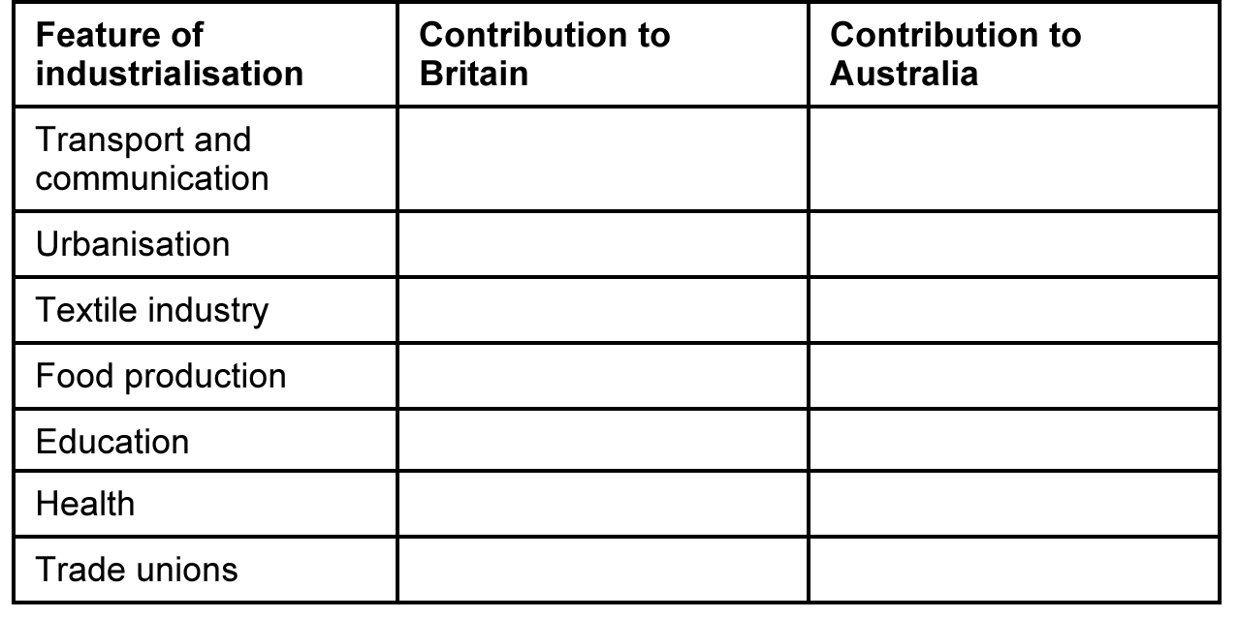  - Use the census data at www.schoolhistory.co.uk/year9links/industrial/population.pdf to explore changes in population and in life expectancy. Copy and paste data from this document to create a more comprehensive list.  - Revise earlier work done on the effects of the agricultural revolution.  - Give reasons for British people leaving their homes and going to other countries, especially within the British Empire.  - Use the following broad categories of lower, middle and upper class. Use ICT and other resources to allocate various Victorian period occupations into one of the broad categories.  - In Britain during this period, these class divisions were quite rigid. How were the class divisions in Britain reflected in where they lived, what work they did, and what entertainment they enjoyed? Demonstrate this by creating a comparative table for all three classes.  - Use the National Trust of England website or other websites to make a direct comparison of the life of the wealthy with the life of the poor in England during the nineteenth century. One poorhouse site is at www.nationaltrust.org.uk/workhouse/. It can be compared with Ickworth House at www.nationaltrust.org.uk/history/overview/item255236/.  The following websites provide material, including sources, on life in Britain during this period:  - http://media.nationalarchives.gov.uk/index.php/our-ancestors-and-the-fear-of-the-victorian-workhouse/ (the Poor Laws and workhouse system)  - http://en.wikipedia.org/wiki/Social_structure_of_the_United_Kingdom (this would be an ideal opportunity to evaluate Wikipedia as a resource)  - www.bbc.co.uk/history/british/victorians/bsurface_01.shtml  - www.ukcensusonline.com/?gclid=CNTP382Qva8CFURypAodrmSixQ  - www.localhistories.org/19thcent.html  - www.shelbycs.org/ms/media%20center/victorian%20england/  - www.hiddenlives.org.uk/articles/poverty.html  - www.spartacus.schoolnet.co.uk/REVhistoryIR2.htm  - www.nettlesworth.durham.sch.uk/time/victorian/vindust.html  - www.bbc.co.uk/history/british/victorians/  - www.historylearningsite.co.uk/industrial_revolution_towns.htm  - www.uncp.edu/home/rwb/manchester_19c.html.  - Students consider their own lifestyle now and discuss what they do, how they spend their time, what they eat, etc. The teacher outlines some of the current laws governing child labour and explains that during the Industrial Revolution, child labour was common in factories and in the mines.  - Using ICT and other sources, students collect and analyse data on how coal mines operated in England during the nineteenth century.  - Students draw a picture of a coal mine, showing the shaft and tunnels using the following: www.theotherside.co.uk/tm-heritage/background/coal-mine-diag.htm.  - Students research life in the mines for children, using sources, such as the following, that emphasise the hazards of working in the mines: www.cartage.org.lb/en/themes/sciences/Earthscience/Geology/Coal/CoalMining/Hazardsof19th/Hazardsof19th.htm.  Parliamentary Inquiry into Child Labour: Students research a character who would be involved in giving evidence for the Inquiry. Each student chooses a character, such as a child working in a factory or mine, a factory owner, a mine owner, a campaigner against child labour, a supporter of child labour, a doctor opposing child labour, etc.  - Each student then researches their characters and their views on child labour and investigates further background evidence:  - www.spartacus.schoolnet.co.uk/Twork.htm  - www.schoolhistory.co.uk/year9links/industrial/children.pdf  - www.schoolhistory.co.uk/year9links/industrial/childworkers.pdf.  - Each student writes a brief biography of their character and prepares the evidence that they will present to the Parliamentary Inquiry. After the class presents their evidence, they will vote as the Parliament on whether or not to abolish child labour.  - Review the effects of the Industrial Revolution.  Complete the following table:  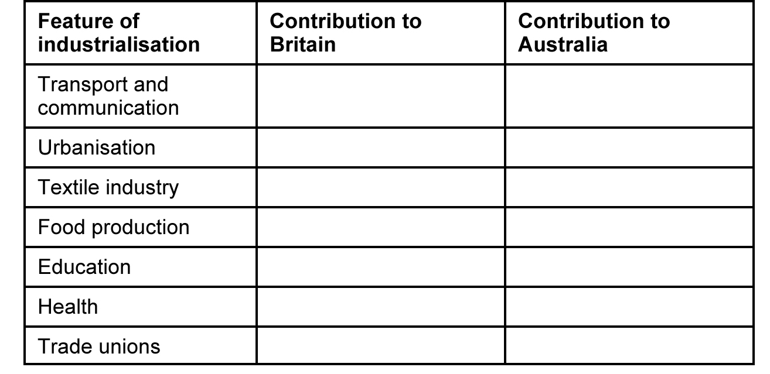  The impact of the Industrial Revolution can be examined through several examples:  Global changes in landscape (can be studied through the case study of Sunlight Soap)  - Discuss the ways the development of Sunlight Soap affected Liverpool and, particularly, the village of Port Sunlight. Use ICT and other sources to explore how the production of palm oil affected both Nigeria and, later, Malaysia, as a case study in the global changes to the landscape.  One such case study is the production of Sunlight Soap by the Lever Brothers at their factory in Port Sunlight.  Additional information is at the end of this unit.  Textiles and the growth of Manchester  - Map the growth of Manchester from 1750 to 1900.  - Tabulate the growth of Manchester from 1750 to 1900.  - Identify the source of Manchester’s raw material and explain why its growth was so rapid.  Changes in transport  - List the types of transport used in 1750 and calculate how fast the systems were and how much can be carried by each form of transport.  - Map the growth of the canal system across England and discuss the advantages of canals over roads at that time.  - Map the growth of railways across England and explain the ways railways contributed to the growth and spread of the Industrial Revolution.  Use www.schoolhistory.co.uk/year9links/industrial/Impactrailways.pdf to access primary sources for this study.  - Work in groups to explain and assess the importance of one of the following individuals to changes in transport during the Industrial Revolution: IK Brunel, R Stephenson, G Stephenson, T Telford, R Fulton and J Brindley.  Changes in communication  - Record the inventions that changed communication during the nineteenth century and place them on a timeline.  - Assess the impact of each change.  - Map the spread of the telegraph line and discuss its impact on the Australian colonies, using http://en.wikipedia.org/wiki/History_of_telegraphy_in_Australia (the role of the telegraph in the Australian colonies). | Life Skills  Students view a selection of images of the Industrial Revolution. What do these sites tell us about this period of time? (Teacher to guide student responses to ideas such as work, machines, technology.)  What was life like before the Industrial Revolution? Students examine the first page of statistics on population growth from the link provided and complete some guided questions, eg:  - Were there more people before or after the Industrial Revolution?  - The number of people living in towns increased/decreased (select one).  - Did men and women live longer after the Industrial Revolution?  - Did more babies survive before or after the Industrial Revolution?  Students listen to the story of a typical rural family before the Industrial Revolution and view related images. They participate in or observe the class discussion about rural life.  Students recognise one or more innovations from the Industrial Revolution, eg photography, phonograph, steam engine, spinning jenny. They find a picture of the original innovation and a picture of the innovation today. Students respond to guided questions, such as:  - Who invented it?  - When was it invented?  - Why is the innovation important to us today?  Students perform a task using a technological innovation and consider how the task would be different without that innovation, eg make a phone call, send a text message, send an email, type a report, catch a train, take a photograph.  Students participate in the role-play of a rural family dealing with the changes occurring around them. After viewing the role-plays, students identify some of the problems faced by rural families.  Students listen to, read or view a story of a protest against the conditions of the time, eg the tossing of shoes (sabots) into machines to protest machine replacement of workers. Students identify/discuss how the workers were feeling during this time. They locate another source showing how the workers felt and present this to the class. This may be done through:  - displaying and describing the source to the class  - creating a visual representation of the source and presenting this to the class  - creating a multimedia presentation using the source.  Students view a film depicting city and/or rural life during the Industrial Revolution. Suggested films include:  - Hard Times (1994, BBC)  - Moulin Rouge (2001, Baz Luhrmann)  - Oliver Twist (2005, Roman Polanski).  Students identify the conditions of life during this time. This may be done through:  - selecting images from the film that best describe living conditions  - identifying words to describe living conditions  - completing a cloze passage or guided questions  - describing what life was like for one of the characters in the film and the difficulties faced  - creating a multimedia presentation showing the living conditions for one or more characters and the difficulties they faced.  Students view images and/or read about the life of the wealthy and the life of the poor in England during the nineteenth century. The poorhouse and Ickworth House sites included may be used. Students identify some of the differences in ways of life for the wealthy and the poor.  Students complete online activities as appropriate relating to factory conditions during the Industrial Revolution:  - www.schoolhistory.co.uk/lessons/industrialrevolution/industrialindex.htm.  Students participate in or observe the class discussion on current lifestyles of students, current laws governing child labour, and child labour during the Industrial Revolution.  Students explore conditions for children working in nineteenth-century factories. Information and activities from the following sources can be used as appropriate:  - www.schoolhistory.co.uk/year9links/industrial/children.pdf  - www.schoolhistory.co.uk/year9links/industrial/childworkers.pdf.  Students create a collage showing conditions for child workers.  Students read about life from a child worker’s point of view. Select from one of the girl or boy child workers at:  - www.spartacus.schoolnet.co.uk/Twork.htm.  As the selected child worker, write a letter or journal entry describing a typical working day.  Students observe the evidence presented by classmates to the Parliamentary Inquiry. They participate in the vote on whether or not to abolish child labour.  Students reflect on what has been learnt about the Industrial Revolution. This may be done through guided questions or a PMI (plus–minus–interesting) chart.

Background information
Protests during the Industrial Revolution
- The Rebecca Riots took place in the rural parts of west Wales, including Pembrokeshire, Cardiganshire and Carmarthenshire, from 1839 to 1843. They were a series of protests made by tenant farmers against the payment of tolls (fees) charged to use the roads. Turnpike Trusts, or groups of businessmen, owned most of the main roads. These men fixed the charges and decided how many tollgates (turnpikes) could be built.
- During the riots, men disguised as women attacked the tollgates. They called themselves ‘Rebecca and her daughters’. This is most likely to be after a passage in the Bible where Rebecca talks of the need to ‘possess the gates of those who hate them’ (Genesis XXIV, verse 60). People at that time knew the Bible well.
- Tolls were a big expense for small farmers, who used the roads to take their crops and animals to market, and also to collect lime (a chalky mineral). Lime was used to improve the quality of the soil so that farmers could grow better crops. It could cost as much as five shillings (25p) in tolls to move a cart of lime eight miles inland. The people of west Wales did not want to pay to use their road.
- www.nationalarchives.gov.uk/education/lessons/lesson48.htm (Rebecca Riots)
- www.spartacus.schoolnet.co.uk/PRluddites.htm (Luddites)
- www.nationalarchives.gov.uk/education/politics/g3/ (Luddites)
Sunlight Soap
- See archives@unilever.com.
- William Lever, the son of a wholesale grocer, was born in Bolton in Lancashire in 1851. He joined the family business when he was 16 and five years later his father made him his partner. In the 1880s, Lever became bored with grocery and began exploring the possibility of expanding into other areas. He eventually decided on soap and, after leasing a chemical works in Warrington in Cheshire, he started experimenting with different ingredients. Lever eventually settled on the formula of palm kernel oil, cottonseed oil, resin and tallow. He called it Sunlight Soap and it was an immediate success. The Warrington factory was not large enough to supply the demand, so Lever built a new factory by the River Mersey in Cheshire. The place was named Port Sunlight after the soap it was to produce. He also built a model town to house his workers. By 1895, Port Sunlight was producing 40,000 tons of soap a year. Other products produced at Port Sunlight included Lifebuoy Carbolic Soap, Sunlight Soap Flakes and Vim. Lever gave a considerable amount of money to charity and his contribution to society was recognised when he was granted the title Viscount Leverhulme. He died in 1925.
- www.unilever.com/aboutus/ourhistory/1885_1900/
- http://en.wikipedia.org/wiki/Sunlight_(cleaning_product)

Resources
Clips/Video series
www.ehs.org.uk/ehs/podcasts/tawney2010.asp
The Victorians (Jeremy Paxman), BBC, 2009, www.bbc.co.uk/programmes/b00hvg67
The Story of Wales (Huw Edwards), BBC, 2012, www.bbc.co.uk/programmes/p00mlrq9
Books and articles
Chesney, K, The Victorian Underworld, Harmondsworth: Penguin, 1972
Cole, G and Postgate, P, The Common People, London: Methuen & Co, 1966
Deary, T, The Vile Victorians (Horrible Histories), London: Scholastic Children’s Books, 1994
Himmelfarb, G, The Idea of Poverty: England in the Early Industrial Age, London: Faber, 1984, pp 376–77
Horn, P, The Victorian Town Child, Stroud: Sutton, 1997
Hughes, A, The Diary of a Farmer’s Wife, 1796–1797, Good Life Press, 2009
Jamieson, A, The Industrial Revolution, London: Edward Arnold, 1982
Kelly, N, Rees, R and Shuter, J, Britain 1750–1900 (Living through History), Oxford: Heinemann, 1998
Mayhew, H, London Labour and the London Poor, London: Penguin, 1985 (originally published 1851)
Mingay, G, Rural Life in Victorian England, London: Heinemann, 1977
Moss, P, History Alive 3 1789–1914, Oadby Leicester: Blond Educational, 1968
Royston Pike, E, Human Documents of the Industrial Revolution in Britain, London: Routledge, 2006
Smith, N, The Industrial Revolution (Events and Outcomes Series), London: Evans Brothers, 2002
Williams, B, Victorian Britain (The Pitkin History of Britain), Andover: Jarrod, 2005

