NSW Syllabus
for the Australian
curriculum

Chemistry

Stage 6

Syllabus

Original published version updated:
March 2017 – NESA Official Notice 30 March 2017 (NESA 18/17)
June 2017 – NESA Official Notice 22 June 2017 (NESA 23/17)
January 2018 – NESA Official Notice 29 January 2018 (NESA 1/18)

© 2017 NSW Education Standards Authority (NESA) for and on behalf of the Crown in right of the State of New South Wales.

The NESA website holds the ONLY official and up-to-date versions of these documents available on the internet. ANY other copies of these documents, or parts of these documents, that may be found elsewhere on the internet might not be current and are NOT authorised. You CANNOT rely on copies from any other source.

The documents on this website contain material prepared by NESA for and on behalf of the Crown in right of the State of New South Wales. The material is protected by Crown copyright.

All rights reserved. No part of the Material may be reproduced in Australia or in any other country by any process, electronic or otherwise, in any material form, or transmitted to any other person or stored electronically in any form without the prior written permission of NESA, except as permitted by the Copyright Act 1968.

When you access the material you agree:
- to use the material for information purposes only
- to reproduce a single copy for personal bona fide study use only and not to reproduce any major extract or the entire material without the prior permission of NESA.
- to acknowledge that the material is provided by NESA.
- to include this copyright notice in any copy made
- not to modify the material or any part of the material without the express prior written permission of NESA.
The material may contain third-party copyright materials such as photos, diagrams, quotations, cartoons and artworks. These materials are protected by Australian and international copyright laws and may not be reproduced or transmitted in any format without the copyright owner’s specific permission. Unauthorised reproduction, transmission or commercial use of such copyright materials may result in prosecution.

NESA has made all reasonable attempts to locate owners of third-party copyright material and invites anyone from whom permission has not been sought to contact the Copyright Officer.

Phone: (02) 9367 8289
Fax: (02) 9279 1482
Email: copyright@nesa.nsw.edu.au

Published by
NSW Education Standards Authority
GPO Box 5300
Sydney NSW 2001
Australia

www.educationstandards.nsw.edu.au

DSSP–27616
D2016/58513

Contents
Introduction 4
Chemistry Key 7
Rationale 10
The Place of the Chemistry Stage 6 Syllabus in the K–12 Curriculum 11
Aim 12
Objectives 13
Outcomes 14
Year 11 Course Structure and Requirements 16
Year 12 Course Structure and Requirements 17
Assessment and Reporting 18
Content 19
Chemistry Year 11 Course Content 32
Chemistry Year 12 Course Content 45
Glossary 59

Introduction

Stage 6 Curriculum
NSW Education Standards Authority (NESA) Stage 6 syllabuses have been developed to provide students with opportunities to further develop skills which will assist in the next stage of their lives.

The purpose of Stage 6 syllabuses is to:
- develop a solid foundation of literacy and numeracy
- provide a curriculum structure which encourages students to complete secondary education at their highest possible level
- foster the intellectual, creative, ethical and social development of students, in particular relating to:
  - application of knowledge, understanding, skills, values and attitudes in the fields of study they choose
  - capacity to manage their own learning and to become flexible, independent thinkers, problem-solvers and decision-makers
  - capacity to work collaboratively with others
  - respect for the cultural diversity of Australian society
  - desire to continue learning in formal or informal settings after school
- provide a flexible structure within which students can meet the challenges of and prepare for:
  - further academic study, vocational training and employment
  - changing workplaces, including an increasingly STEM-focused (Science, Technology, Engineering and Mathematics) workforce
  - full and active participation as global citizens
- provide formal assessment and certification of students’ achievements
- promote the development of students’ values, identity and self-respect.

The Stage 6 syllabuses reflect the principles of the NESA K–10 Curriculum Framework and Statement of Equity Principles, the reforms of the NSW Government Stronger HSC Standards (2016), and nationally agreed educational goals. These syllabuses build on the continuum of learning developed in the K–10 syllabuses.

The syllabuses provide a set of broad learning outcomes that summarise the knowledge, understanding, skills, values and attitudes important for students to succeed in and beyond their schooling. In particular, the attainment of skills in literacy and numeracy needed for further study, employment and active participation in society are provided in the syllabuses in alignment with the Australian Core Skills Framework (ACSF).

The Stage 6 syllabuses include the content of the Australian curriculum and additional descriptions that clarify the scope and depth of learning in each subject.

NESA syllabuses support a standards-referenced approach to assessment by detailing the important knowledge, understanding, skills, values and attitudes students will develop and outlining clear standards of what students are expected to know and be able to do. The syllabuses take into account the diverse needs of all students and provide structures and processes by which teachers can provide continuity of study for all students.

Diversity of Learners
NSW Stage 6 syllabuses are inclusive of the learning needs of all students. Syllabuses accommodate teaching approaches that support student diversity, including students with special education needs, gifted and talented students, and students learning English as an additional language or dialect (EAL/D). Students may have more than one learning need.

Students with Special Education Needs
All students are entitled to participate in and progress through the curriculum. Schools are required to provide additional support or adjustments to teaching, learning and assessment activities for some students with special education needs. Adjustments are measures or actions taken in relation to teaching, learning and assessment that enable a student with special education needs to access syllabus outcomes and content, and demonstrate achievement of outcomes.

Students with special education needs can access the outcomes and content from Stage 6 syllabuses in a range of ways. Students may engage with:
- Stage 6 syllabus outcomes and content with adjustments to teaching, learning and/or assessment activities; or
- selected Stage 6 Life Skills outcomes and content from one or more Stage 6 Life Skills syllabuses.

Decisions regarding curriculum options, including adjustments, should be made in the context of collaborative curriculum planning with the student, parent/carer and other significant individuals to ensure that decisions are appropriate for the learning needs and priorities of individual students.

The Science Life Skills Stage 6 Syllabus has been developed from the rationale, aim and objectives of the Investigating Science Stage 6 Syllabus.

Further information can be found in support materials for:
- Chemistry
- Special education needs
- Life Skills.

Gifted and Talented Students
Gifted students have specific learning needs that may require adjustments to the pace, level and content of the curriculum. Differentiated educational opportunities assist in meeting the needs of gifted students.

Generally, gifted students demonstrate the following characteristics:
- the capacity to learn at faster rates
- the capacity to find and solve problems
- the capacity to make connections and manipulate abstract ideas.

There are different kinds and levels of giftedness. Gifted and talented students may also possess learning difficulties and/or disabilities that should be addressed when planning appropriate teaching, learning and assessment activities.

Curriculum strategies for gifted and talented students may include:
- differentiation: modifying the pace, level and content of teaching, learning and assessment activities
- acceleration: promoting a student to a level of study beyond their age group
- curriculum compacting: assessing a student’s current level of learning and addressing aspects of the curriculum that have not yet been mastered.

School decisions about appropriate strategies are generally collaborative and involve teachers, parents and students with reference to documents and advice available from NESA and the education sectors.

Gifted and talented students may also benefit from individual planning to determine the curriculum options, as well as teaching, learning and assessment strategies, most suited to their needs and abilities.

Students Learning English as an Additional Language or Dialect (EAL/D)
Many students in Australian schools are learning English as an additional language or dialect (EAL/D). EAL/D students are those whose first language is a language or dialect other than Standard Australian English and who require additional support to assist them to develop English language proficiency.

EAL/D students come from diverse backgrounds and may include:
- overseas and Australian-born students whose first language is a language other than English, including creoles and related varieties
- Aboriginal and Torres Strait Islander students whose first language is Aboriginal English, including Kriol and related varieties.

EAL/D students enter Australian schools at different ages and stages of schooling and at different stages of English language learning. They have diverse talents and capabilities and a range of prior learning experiences and levels of literacy in their first language and in English. EAL/D students represent a significant and growing percentage of learners in NSW schools. For some, school is the only place they use Standard Australian English.

EAL/D students are simultaneously learning a new language and the knowledge, understanding and skills of the Chemistry Stage 6 Syllabus through that new language. They may require additional support, along with informed teaching that explicitly addresses their language needs.

The ESL Scales and the English as an Additional Language or Dialect: Teacher Resource provide information about the English language development phases of EAL/D students. These materials and other resources can be used to support the specific needs of English language learners and to assist students to access syllabus outcomes and content.

Chemistry Key
The following codes and icons are used in the Chemistry Stage 6 Syllabus.

Outcome Coding
Syllabus outcomes have been coded in a consistent way. The code identifies the subject, Year and outcome number. For example:
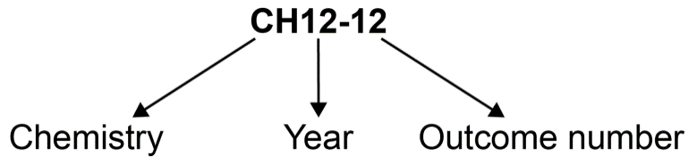

Outcome code | Interpretation
CH11/12-1 | Chemistry – outcome number 1
CH11-8 | Year 11 Chemistry – outcome number 8
CH12-12 | Year 12 Chemistry – outcome number 12

Working Scientifically outcomes 1–7 are common across Year 11 and Year 12.

Knowledge and Understanding outcomes in Year 11 are numbered 8–11.

Knowledge and Understanding outcomes in Year 12 are numbered 12–15.

Coding of Australian Curriculum Content
Australian curriculum content descriptions included in the syllabus are identified by an Australian curriculum code which appears in brackets at the end of each content description. For example:
Conduct investigations, including the use of devices to accurately measure temperature change and mass, safely, competently and methodically for the collection of valid and reliable data (ACSCH003).

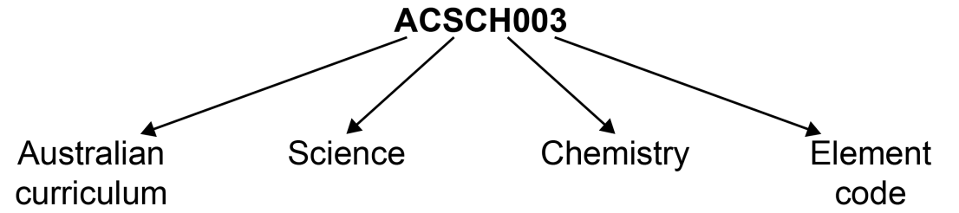

Where a number of content descriptions are jointly represented, all description codes are included, for example (ACSCH001, ACSCH002, ACSCH003).

Learning Across the Curriculum Icons
Learning across the curriculum content, including cross-curriculum priorities, general capabilities and other areas identified as important learning for all students, is incorporated and identified by icons in the syllabus.

Cross-curriculum priorities
Aboriginal and Torres Strait Islander histories and cultures
Asia and Australia’s engagement with Asia
Sustainability

General capabilities
Critical and creative thinking
Ethical understanding
Information and communication technology capability
Intercultural understanding
Literacy
Numeracy
Personal and social capability

Other learning across the curriculum areas
Civics and citizenship
Difference and diversity
Work and enterprise

Rationale
The Chemistry Stage 6 Syllabus explores the structure, composition and reactions of and between all elements, compounds and mixtures that exist in the Universe. The discovery and synthesis of new compounds, the monitoring of elements and compounds in the environment, and an understanding of industrial processes and their applications to life processes are central to human progress and our ability to develop future industries and sustainability.

The course further develops an understanding of chemistry through the application of Working Scientifically skills. It focuses on the exploration of models, understanding of theories and laws, and examination of the interconnectedness between seemingly dissimilar phenomena.

Chemistry involves using differing scales, specialised representations, explanations, predictions and creativity, especially in the development and pursuit of new materials. It requires students to use their imagination to visualise the dynamic, minuscule world of atoms in order to gain a better understanding of how chemicals interact.
The Chemistry course builds on students’ knowledge and skills developed in the Science Stage 5 course and increases their understanding of chemistry as a foundation for undertaking investigations in a wide range of Science, Technology, Engineering and Mathematics (STEM) related fields. A knowledge and understanding of chemistry is often the unifying link between interdisciplinary studies.
The course provides the foundation knowledge and skills required to study chemistry after completing school, and supports participation in a range of careers in chemistry and related interdisciplinary industries. It is an essential discipline that currently addresses and will continue to address our energy needs and uses, the development of new materials, and sustainability issues as they arise.

The Place of the Chemistry Stage 6 Syllabus in the K–12 Curriculum

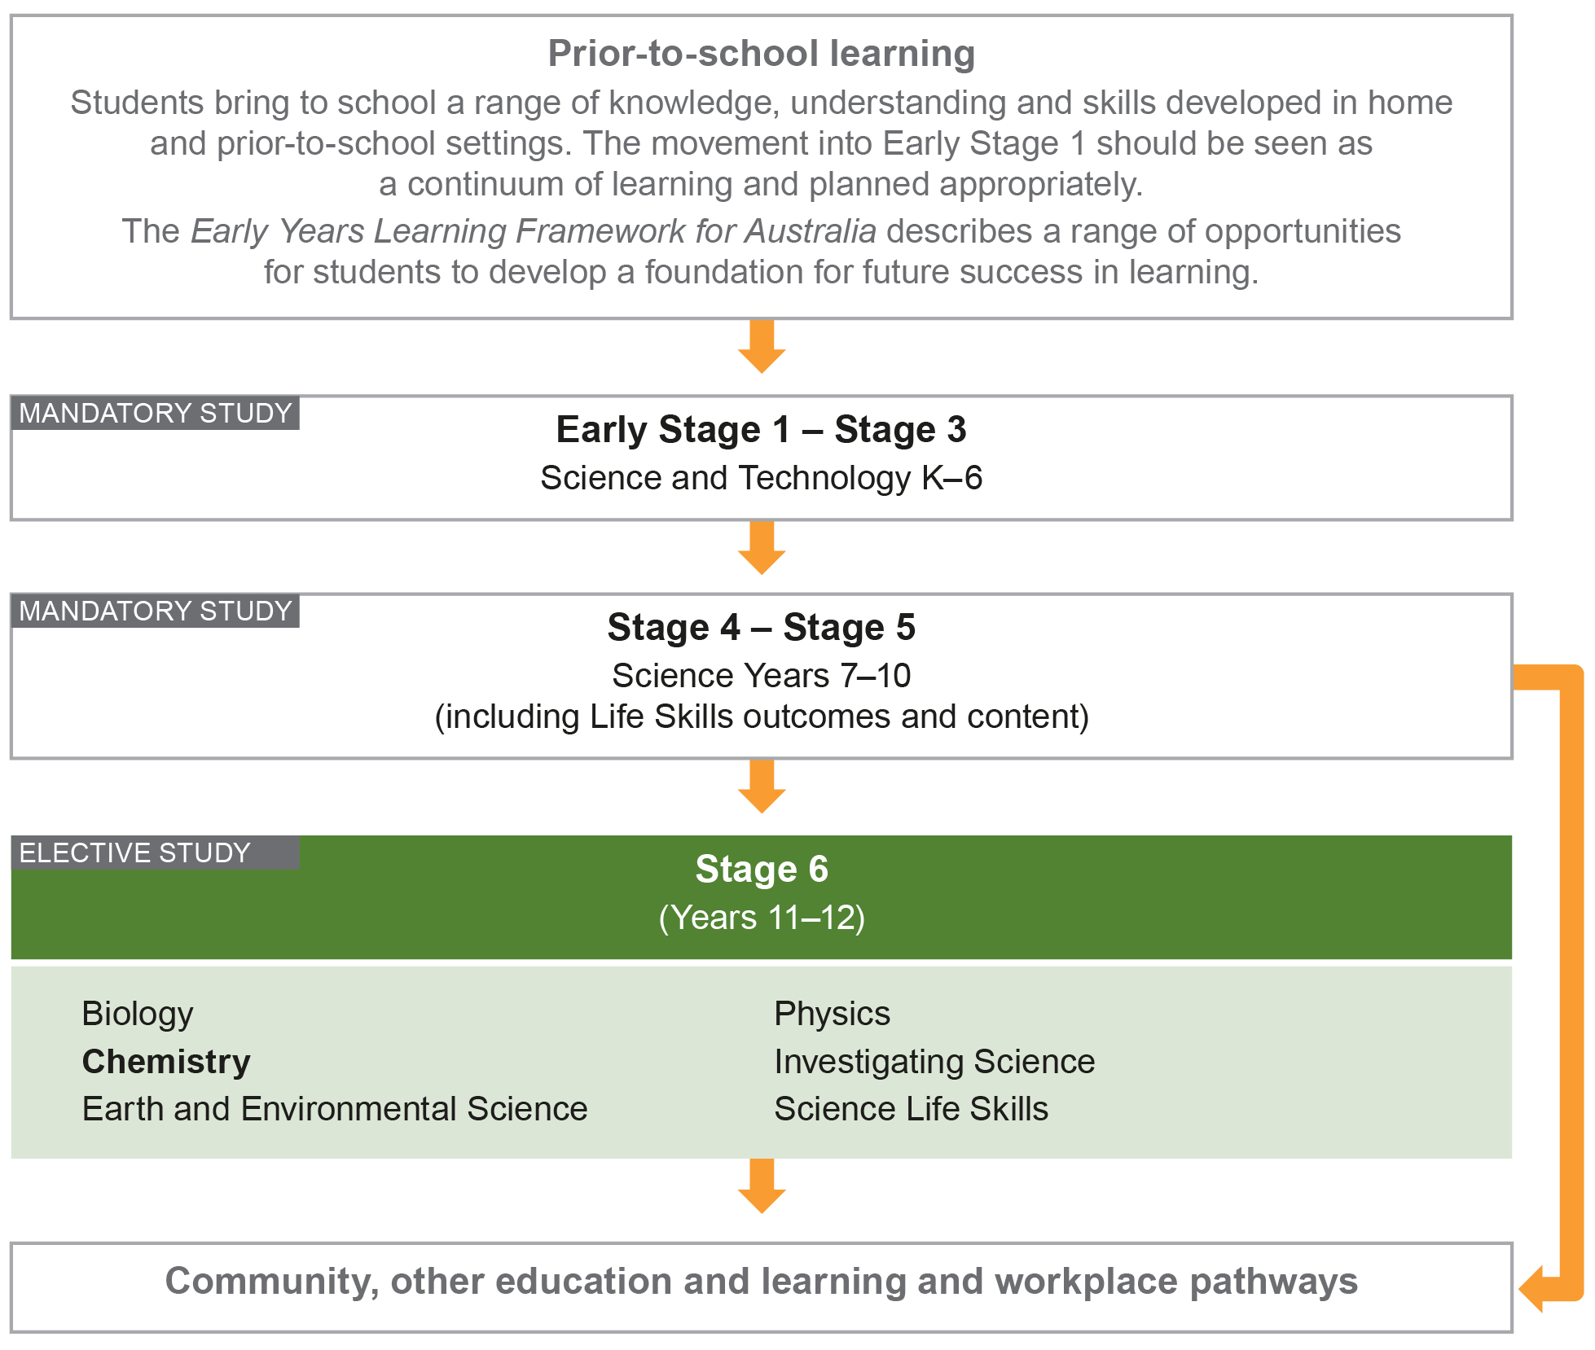

Aim
The study of Chemistry in Stage 6 enables students to develop an appreciation and understanding of materials and their properties, structures, interactions and related applications. Through applying Working Scientifically skills processes, the course aims to examine how chemical theories, models and practices are used and developed.

Objectives

Skills
Students:
- develop skills in applying the processes of Working Scientifically.

Knowledge and Understanding
Year 11 students:
- develop knowledge and understanding of the fundamentals of chemistry
- develop knowledge and understanding of the trends and driving forces in chemical interactions.

Year 12 students:
- develop knowledge and understanding of equilibrium and acid reactions
- develop knowledge and understanding of the applications of chemistry.

Values and Attitudes
Students:
- develop positive, informed values and attitudes towards chemistry
- recognise the importance and relevance of chemistry in their lives
- recognise the influence of economic, political and societal impacts on the development of scientific knowledge
- develop an appreciation of the influence of imagination and creativity in scientific research.

Outcomes

Table of Objectives and Outcomes – Continuum of Learning

Skills
Objective
Students:
- develop skills in applying the processes of Working Scientifically
Stage 6 course outcomes
A student:
Questioning and predicting
CH11/12-1 develops and evaluates questions and hypotheses for scientific investigation
Planning investigations
CH11/12-2 designs and evaluates investigations in order to obtain primary and secondary data and information
Conducting investigations
CH11/12-3 conducts investigations to collect valid and reliable primary and secondary data and information
Processing data and information
CH11/12-4 selects and processes appropriate qualitative and quantitative data and information using a range of appropriate media
Analysing data and information
CH11/12-5 analyses and evaluates primary and secondary data and information
Problem solving
CH11/12-6 solves scientific problems using primary and secondary data, critical thinking skills and scientific processes
Communicating
CH11/12-7 communicates scientific understanding using suitable language and terminology for a specific audience or purpose

The Working Scientifically outcomes at the beginning of each module are targeted for emphasis. The other Working Scientifically outcomes may also be addressed in each module.

Knowledge and Understanding
Year 11 course | Year 12 course
Objective  Students:  - develop knowledge and understanding of the fundamentals of chemistry | Objective  Students:  - develop knowledge and understanding of equilibrium and acid reactions in chemistry
Year 11 course outcomes  A student: | Year 12 course outcomes  A student:
CH11-8 explores the properties and trends in the physical, structural and chemical aspects of matter | CH12-12 explains the characteristics of equilibrium systems, and the factors that affect these systems
CH11-9 describes, applies and quantitatively analyses the mole concept and stoichiometric relationships | CH12-13 describes, explains and quantitatively analyses acids and bases using contemporary models
Objective  Students:  - develop knowledge and understanding of the trends and driving forces in chemical interactions | Objective  Students:  - develop knowledge and understanding of the applications of chemistry
Year 11 course outcomes  A student: | Year 12 course outcomes  A student:
CH11-10 explores the many different types of chemical reactions, in particular the reactivity of metals, and the factors that affect the rate of chemical reactions | CH12-14 analyses the structure of, and predicts reactions involving, carbon compounds
CH11-11 analyses the energy considerations in the driving force for chemical reactions | CH12-15 describes and evaluates chemical systems used to design and analyse chemical processes

Year 11 Course Structure and Requirements
Year 11 course  (120 hours) | Working Scientifically Skills | Modules | Indicative hours | Depth studies
 |  | Module 1  Properties and Structure of Matter | 60 | *15 hours  in Modules 1–4
Module 2
Introduction to Quantitative Chemistry
 |  | Module 3  Reactive Chemistry | 60
Module 4
Drivers of
Reactions

*15 hours must be allocated to depth studies within the 120 indicative course hours.

Requirements for Practical Investigations
Scientific investigations include both practical investigations and secondary-sourced investigations. Practical investigations are an essential part of the Year 11 course and must occupy a minimum of
35 hours of course time, including time allocated to practical investigations in depth studies.

Practical investigations include:
- undertaking laboratory experiments, including the use of appropriate digital technologies
- fieldwork.

Secondary-sourced investigations include:
- locating and accessing a wide range of secondary data and/or information
- using and reorganising secondary data and/or information.

Year 12 Course Structure and Requirements
Year 12 course  (120 hours) | Working Scientifically Skills | Modules | Indicative hours | Depth studies
 |  | Module 5  Equilibrium and Acid Reactions | 60 | *15 hours  in Modules 5–8
Module 6
Acid/base Reactions
 |  | Module 7  Organic Chemistry | 60
Module 8
Applying
Chemical Ideas

*15 hours must be allocated to depth studies within the 120 indicative course hours.

Requirements for Practical Investigations
Scientific investigations include both practical investigations and secondary-sourced investigations. Practical investigations are an essential part of the Year 12 course and must occupy a minimum of
35 hours of course time, including time allocated to practical investigations in depth studies.

Practical investigations include:
- undertaking laboratory experiments, including the use of appropriate digital technologies
- fieldwork.

Secondary-sourced investigations include:
- locating and accessing a wide range of secondary data and/or information using and reorganising secondary data and/or information.

Assessment and Reporting
Information about assessment in relation to the Chemistry syllabus is contained in Assessment and Reporting in Chemistry Stage 6. It outlines course-specific advice and requirements regarding:
- Year 11 and Year 12 school-based assessment requirements
- Year 11 and Year 12 mandatory components and weightings
- External assessment requirements including HSC examination specifications.

This information should be read in conjunction with requirements on the Assessment Certification Examination (ACE) website.

Additional advice is available in the Principles of Assessment for Stage 6.

Content
Content defines what students are expected to know and do as they work towards syllabus outcomes. It provides the foundations for students to successfully progress to the next stage of schooling or post-school opportunities.
Teachers will make decisions about content regarding the sequence, emphasis and any adjustments required based on the needs, interests, abilities and prior learning of students.
Content in Stage 6 syllabuses defines learning expectations that may be assessed in Higher School Certificate examinations.

Organisation of Content
The following diagram provides an illustrative representation of elements of the course and their relationship.

The Year 11 and Year 12 courses each comprise four modules. The skills of Working Scientifically are integrated as course content throughout the syllabus. Each module includes a specific focus on some of the Working Scientifically skills. However, there is scope within each module to engage with all of the Working Scientifically skills.

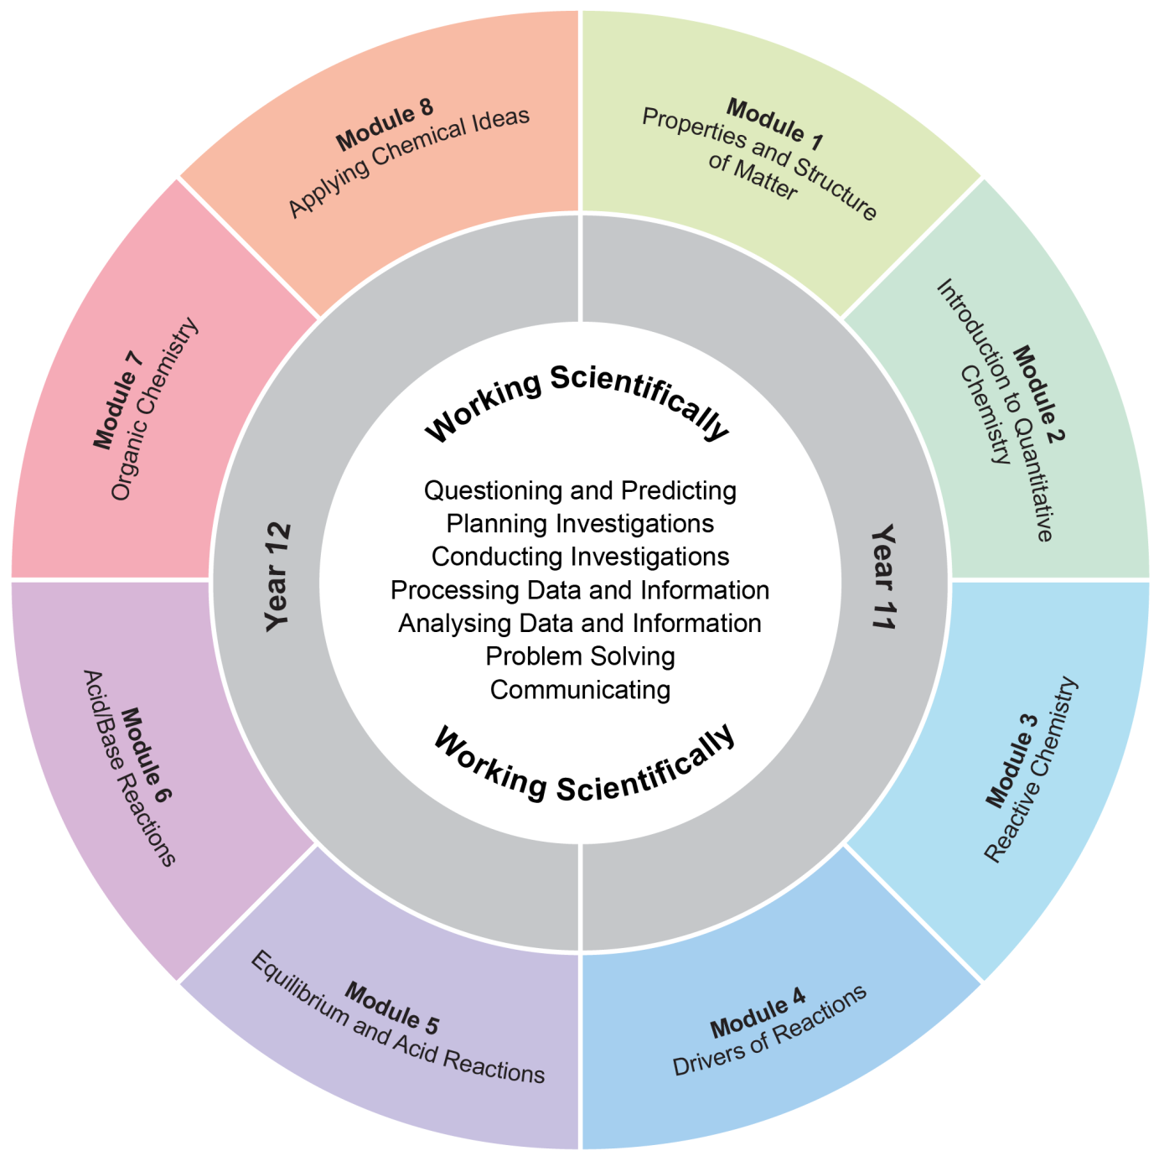

The Working Scientifically outcomes and content are integrated into each module wherever students undertake an investigation.

Working Scientifically
Working Scientifically skills are at the core of conducting practical and secondary-sourced investigations in science.

Opportunities should be provided for students to engage with all the Working Scientifically skills in investigations. In each module, particular outcomes have been identified as those that are most relevant to the intended learning.

Students are challenged to further develop their understanding of Working Scientifically as a group of dynamic and interdependent processes that are applied in each scientific investigation in a way that is appropriate and determined by the activity. This dynamism and interrelatedness adds a level of sophistication to students’ understanding of the true nature and practice of science. Through regular involvement in these processes, applying them as appropriate, in a range of varied practical investigations, students can broaden their interpretation of Working Scientifically beyond the common linear model.

Students are encouraged to select the most appropriate gateway to the Working Scientifically processes. The pathways within the processes become self-evident through the nature of the investigation. An investigation may be instigated by, for example:
- direct observation of a phenomenon
- inconsistencies arising from results of a related investigation
- the qualitative and quantitative analysis of data
- secondary-sourced research.

Students are challenged to be open to:
- refining or redeveloping their chosen procedures
- redefining their questions and/or hypotheses
- modifying their methodologies or designs
- conducting further practical investigations
- conducting further secondary research.

Students are also encouraged to communicate evidence-based conclusions and suggest ideas for future research. Unexpected results are to be welcomed to refine methodologies and to generate further investigation. Knowledge and understanding of science is essential to these processes. Through this practice of science, students can acquire a deeper knowledge and understanding of scientific concepts.

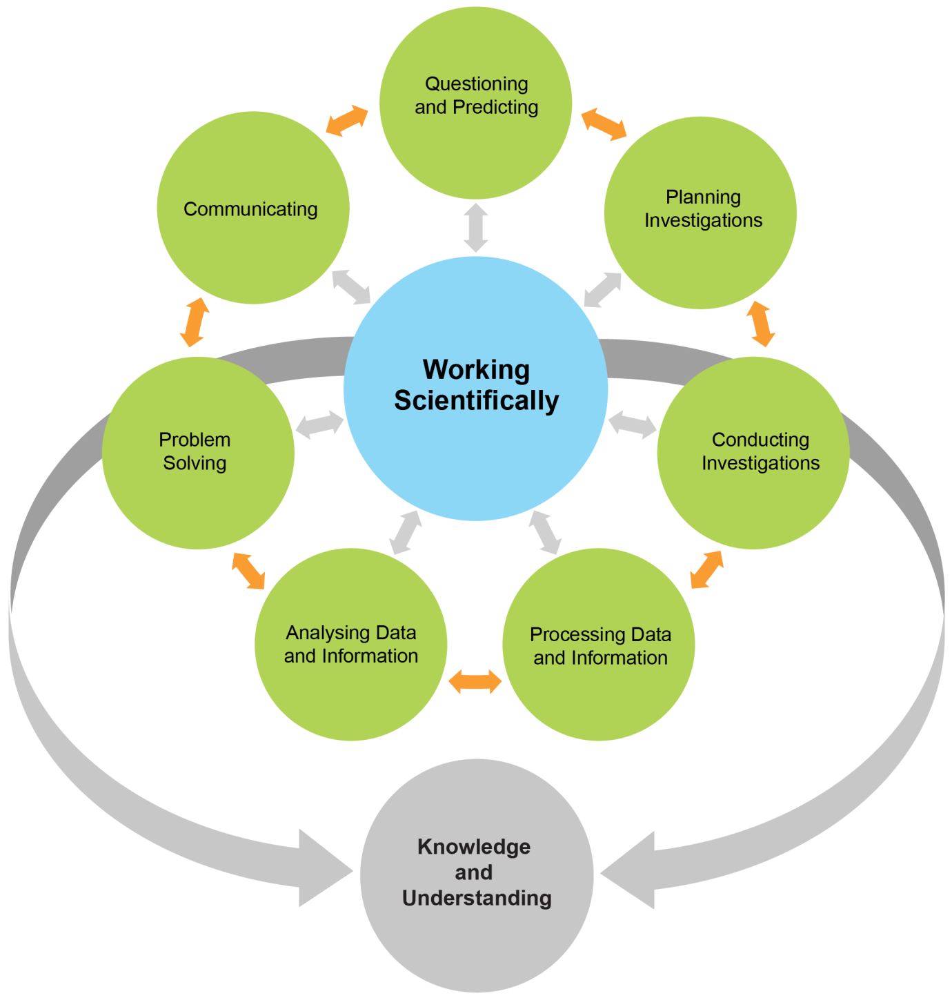
Each of the seven Working Scientifically outcomes represents one of the interdependent dynamic processes that are central to the study of science and the acquisition of scientific knowledge and skills. This course is structured to provide ongoing opportunities for students to implement these processes, particularly through the depth study provision. The following descriptions of the Working Scientifically outcomes provide further information about the skills students are expected to develop throughout the course.

Questioning and Predicting
Developing, proposing and evaluating inquiry questions and hypotheses challenges students to identify an issue or phenomenon that can be investigated scientifically by gathering primary and/or secondary-sourced data. Students develop inquiry question(s) that require observations, experimentation and/or research to aid in constructing a reasonable and informed hypothesis. The consideration of variables is to be included in the questioning process.

Planning Investigations
Students justify the selection of equipment, resources chosen and design of an investigation. They ensure that all risks are assessed, appropriate materials and technologies are sourced, and all ethical concerns are considered. Variables are to be identified as independent, dependent and controlled to ensure a valid procedure is developed that will allow for the reliable collection of data. Investigations should include strategies that ensure controlled variables are kept constant and an experimental control is used as appropriate.

Conducting Investigations
Students are to select appropriate equipment, employ safe work practices and ensure that risk assessments are conducted and followed. Appropriate technologies are to be used and procedures followed when disposing of waste. The selection and criteria for collecting valid and reliable data is to be methodical and, where appropriate, secondary-sourced information referenced correctly.

Processing Data and Information
Students use the most appropriate and meaningful methods and media to organise and analyse data and information sources, including digital technologies and the use of a variety of visual representations as appropriate. They process data from primary and secondary sources, including both qualitative and quantitative data and information.

Analysing Data and Information
Students identify trends, patterns and relationships; recognise error, uncertainty and limitations in data; and interpret scientific and media texts. They evaluate the relevance, accuracy, validity and reliability of the primary or secondary-sourced data in relation to investigations. They evaluate processes, claims and conclusions by considering the quality of available evidence, and use reasoning to construct scientific arguments. Where appropriate, mathematical models are to be applied to demonstrate the trends and relationships that occur in data.

Problem Solving
Students use critical thinking skills and creativity to demonstrate an understanding of scientific principles underlying the solutions to inquiry questions and problems posed in investigations. Appropriate and varied strategies are employed, including the use of models, to qualitatively and quantitatively and explain and predict cause-and-effect relationships. In Working Scientifically, students synthesise and use evidence to construct and justify conclusions. To solve problems, students: interpret scientific and media texts; evaluate processes, claims and conclusions; and consider the quality of available evidence.

Communicating
Communicating all components of the Working Scientifically processes with clarity and accuracy is essential. Students use qualitative and quantitative information gained from investigations using primary and secondary sources, including digital, visual, written and/or verbal forms of communication as appropriate. Students apply appropriate scientific notations and nomenclature. They also appropriately apply and use scientific language that is suitable for specific audiences and contexts.

Investigations
An investigation is a scientific process to answer a question, explore an idea or solve a problem. Investigations include activities such as planning a course of action, collecting data, processing and analysing data, reaching a conclusion and communicating. Investigations may include the collection of primary and/or secondary-sourced data or information.

Practical investigations involve the collection of primary data. They may include:
- undertaking laboratory investigations, including fair tests and controlled experiments
- undertaking fieldwork and surveys
- constructing models.

Secondary-sourced investigations can include:
- researching by using a variety of media
- extracting and reorganising secondary-sourced information in the form of flow charts, tables, graphs, diagrams, prose, keys, spreadsheets and databases
- using models to inform understanding.

Safety
Schools have a legal obligation in relation to safety. Teachers will need to ensure that they comply with relevant legislation as well as system and school requirements in relation to safety when implementing their programs. This includes legislation and guidelines relating to Work Health and Safety, and the handling and storage of chemical and dangerous goods.

Animal Research
Schools have a legal responsibility in relation to the welfare of animals. The keeping of animals and all practical activities involving animals must comply with relevant guidelines or legislation.

Inquiry Questions
Inquiry questions are included in the course content and used to frame the syllabus content within each module. The depth of knowledge and understanding and skill development required to fully address the inquiry questions may vary. This allows for differentiation of the course content to cater for the diversity of learners.

Depth Studies: Year 11 and Year 12

What are Depth Studies?
A depth study is any type of investigation/activity that a student completes individually or collaboratively that allows the further development of one or more concepts found within or inspired by the syllabus. It may be one investigation/activity or a series of investigations/activities.

Depth studies provide opportunities for students to pursue their interests in chemistry, acquire a depth of understanding, and take responsibility for their own learning. Depth studies promote differentiation and engagement, and support all forms of assessment, including assessment for, as and of learning. Depth studies allow for the demonstration of a range of Working Scientifically skills.

A depth study may be, but is not limited to:
- a practical investigation or series of practical investigations and/or a secondary-sourced investigation or series of secondary-sourced investigations
- presentations, research assignments or fieldwork reports
- the extension of concepts found within the course, either qualitatively and/or quantitatively.

The length of time for any individual study and the pedagogies employed are not prescribed. The time for the depth studies may be allocated to a single study or spread over the year, and incorporate several studies depending on individual school and/or class requirements.

Requirements for Depth Studies
- A minimum of 15 hours of in-class time is allocated in both Year 11 and Year 12.
- At least one depth study must be included in both Year 11 and Year 12.
- The two Working Scientifically outcomes of Questioning and Predicting, and Communicating must be addressed in both Year 11 and Year 12.
- A minimum of two additional Working Scientifically skills outcomes, and further development of at least one Knowledge and Understanding outcome, are to be addressed in all depth studies.

Ideas for Depth Studies

Practical Investigations
- Design and conduct experiments
- Test a claim
- Test a device.

Secondary-sourced Investigations
- Make a documentary or media report
- Conduct a literature review
- Develop an evidence-based argument
- Write a journal article
- Write an essay – historical or theoretical
- Develop an environmental management plan
- Analyse a work of fiction or film for scientific relevance
- Create a visual presentation
- Investigate emerging technologies.

Creating
- Design and invent
- Create a working model
- Create a portfolio.

Fieldwork
Fieldwork may be a starting point for a practical investigation or secondary-sourced study and could be initiated by the following stimuli:
- an excursion
- engagement with community experts.

Data Analysis
Data analysis may be incorporated into a practical investigation or secondary-sourced investigation. For example:
- construction and analysis of graphs/tables
- data analysis from a variety of sources
- research analysis, eg of longitudinal data, resource management data.

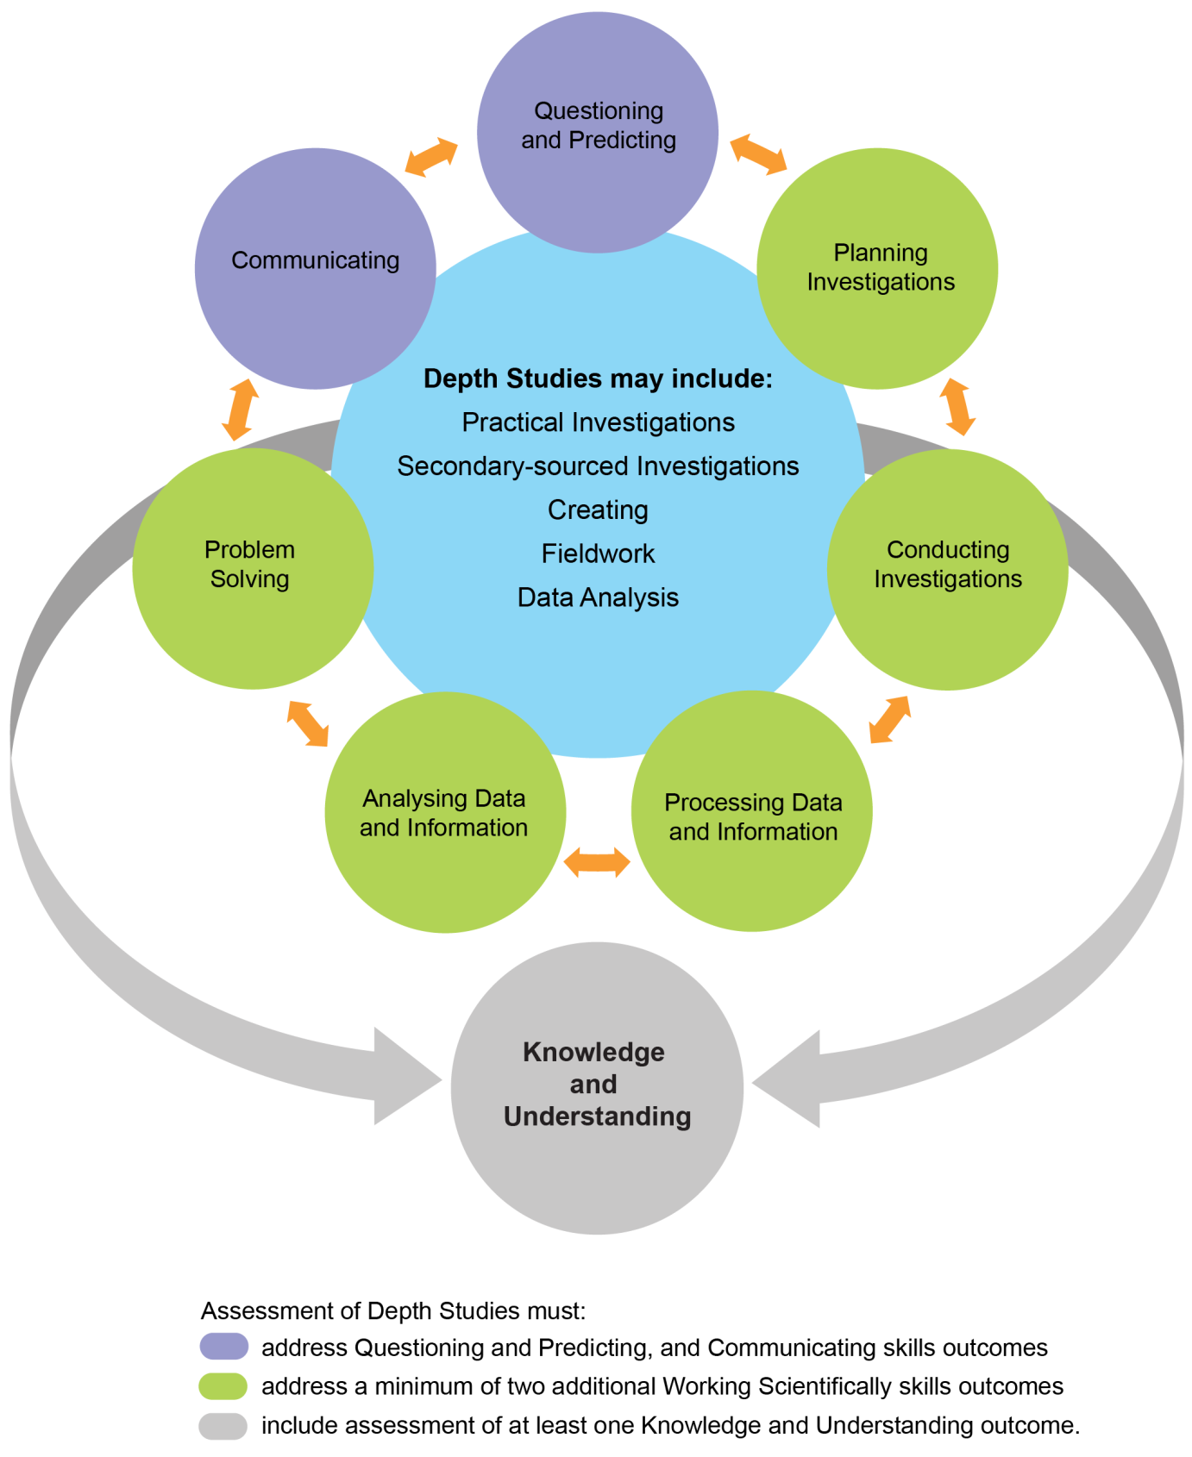

Learning Across the Curriculum
Learning across the curriculum content, including the cross-curriculum priorities and general capabilities, assists students to achieve the broad learning outcomes defined in the NESA Statement of Equity Principles, the Melbourne Declaration on Educational Goals for Young Australians (December 2008) and in the Australian Government’s Core Skills for Work Developmental Framework (2013).

Cross-curriculum priorities enable students to develop understanding about and address the contemporary issues they face.

The cross-curriculum priorities are:
- Aboriginal and Torres Strait Islander histories and cultures
- Asia and Australia’s engagement with Asia
- Sustainability

General capabilities encompass the knowledge, skills, attitudes and behaviours required to assist students to live and work successfully in the 21st century.

The general capabilities are:
- Critical and creative thinking
- Ethical understanding
- Information and communication technology capability
- Intercultural understanding
- Literacy
- Numeracy
- Personal and social capability.

NESA syllabuses include other areas identified as important learning for all students, including:
- Civics and citizenship
- Difference and diversity
- Work and enterprise

Learning across the curriculum content is incorporated, and identified by icons, in the content of the Chemistry Stage 6 Syllabus in the following ways.

Aboriginal and Torres Strait Islander Histories and Cultures
Aboriginal and Torres Strait Islander communities have diverse cultures, social structures and a history of unique, complex knowledge systems. In Chemistry students are provided with opportunities to learn about how Aboriginal and Torres Strait Islander Peoples have developed and refined knowledge about the world through observation, making predictions, testing (trial and error) and responding to environmental factors within specific contexts. Students investigate examples of Aboriginal and Torres Strait Islander Peoples’ understanding of the environment and the ways in which traditional knowledge and Western scientific knowledge can be complementary.

When planning and programming content relating to Aboriginal and Torres Strait Islander histories and cultures teachers are encouraged to:
- involve local Aboriginal communities and/or appropriate knowledge holders in determining suitable resources, or to use Aboriginal or Torres Strait Islander authored or endorsed publications
- read the Principles and Protocols relating to teaching and learning about Aboriginal and Torres Strait Islander histories and cultures and the involvement of local Aboriginal communities.

Asia and Australia’s Engagement with Asia
Asia and Australia’s engagement with Asia provides rich and engaging contexts for developing students’ scientific and technological knowledge, understanding and skills. In Chemistry students are provided with opportunities to recognise that the Asia region includes diverse environments. They are provided with opportunities to appreciate how interactions within and between these environments and the impacts of human activity influence the region, including Australia, and have significance for the rest of the world.

Asia plays an important role in scientific and technological research and development in areas such as medicine, natural resource management and natural disaster prediction and management.

Sustainability
Sustainability is concerned with the ongoing capacity of the Earth to maintain all life. It provides authentic contexts for exploring, investigating and understanding systems in natural and human-made environments. In Chemistry students are provided with opportunities to investigate relationships between systems and system components, and consider the sustainability of food sources and the natural and human environments. They engage in ethical debate and with different perspectives in solving ethical problems.

Critical and Creative Thinking
Critical and creative thinking are integral to activities where students learn to generate and evaluate knowledge, clarify concepts and ideas, seek possibilities, consider alternatives and solve problems. Critical and creative thinking are embedded in the skills and processes of Working Scientifically. In order to make evidence-based decisions, students are provided with opportunities to develop critical and creative thinking skills through: asking and posing questions; making predictions; engaging in practical and secondary-source investigations; and analysing and evaluating evidence.

Ethical Understanding
Students are provided with opportunities to develop the capability to assess ethical values and principles, and to understand how reasoning can assist ethical judgement. In Chemistry students are provided with opportunities to form and make ethical judgements in relation to scientific investigations, design, codes of practice, and the use of scientific information and applications. Students explore the importance of reporting honestly based on evidence. They apply ethical guidelines in their investigations, particularly in regard to the implications for others and the environment.

Information and Communication Technology Capability
Information and communication technology (ICT) can be used effectively and appropriately to access, create and communicate information and ideas, solve problems and work collaboratively. In Chemistry students are provided with opportunities to develop ICT capability when they: develop ideas, concepts and solutions; research science concepts and applications; investigate scientific phenomena; and communicate their scientific and technological understandings. In particular, they have opportunities to learn to: access information; collect, analyse and represent data; model and interpret concepts and relationships; and communicate scientific and technological ideas, processes and information.

Intercultural Understanding
Students develop intercultural understanding as they learn to understand themselves in relation to others. This involves students valuing their own cultures and those of others, and engaging with people of diverse cultures in ways that recognise commonalities and differences, create connections and cultivate respect. In Chemistry students are provided with opportunities to appreciate how diverse cultural perspectives have impacted on the development, breadth and diversity of scientific knowledge and applications. They learn about and engage with issues requiring cultural sensitivity, and learn that scientists work in culturally diverse teams to address issues and solve problems of national and international importance.

Literacy
Literacy is the ability to use a repertoire of knowledge and skills to communicate and comprehend effectively, using a variety of modes and media. Being ‘literate’ is more than the acquisition of technical skills – it includes the ability to identify, understand, interpret, create and communicate effectively using written, visual and digital forms of expression and communication for a number of purposes. In Chemistry students are provided with opportunities to understand that language varies according to the context and engage with different forms of written and spoken language to communicate scientific concepts. They learn that scientific information can also be presented in the form of diagrams, flow charts, tables, graphs and models.

Numeracy
Numeracy involves recognising and understanding the role of mathematics in the world. Students become numerate as they develop the confidence, willingness and ability to apply mathematics in their lives in constructive and meaningful ways. In Chemistry students are provided with opportunities to develop numeracy skills through practical measurement and the collection, representation and interpretation of data from first-hand investigations and secondary sources. Students consider issues of uncertainty and reliability in measurement and have opportunities to learn data analysis skills, identifying trends and patterns from numerical data and graphs. They apply mathematical equations and concepts in order to solve problems.

Personal and Social Capability
Students develop personal and social capability as they learn to understand and manage themselves, their relationships and their lives more effectively. This includes establishing positive relationships, making responsible decisions, working effectively individually and in teams, and constructively handling challenging situations. Through applying the processes of Working Scientifically, students can develop skills in collaboration, peer assessment and review. They plan and conduct a depth study, either individually or in a team.

Civics and Citizenship
Civics and citizenship content involves knowledge and understanding of how our Australian society operates. In Chemistry students are provided with opportunities to broaden their understanding of aspects of civics and citizenship related to the application of scientific ideas and technological advances, including ecological sustainability and the development of environmental and sustainable practices at a local, regional and national level.

Difference and Diversity
Difference and diversity comprise gender, race and socio-economic circumstances. Students are provided with opportunities to understand and appreciate the difference and diversity they experience in their everyday lives. Working Scientifically provides opportunities for students to work collaboratively, where they can develop an appreciation of the values and ideas of all group members. This appreciation also enables students to identify individual rights, challenge stereotypes and engage with opinions that are different to their own.

Work and Enterprise
Students can develop work-related skills and an appreciation of the value of working individually and collaboratively when conducting investigations. In Chemistry students are provided with opportunities for students to prioritise safe practices and understand the potential risks and hazards present when conducting investigations. They engage with risk assessment while working safely in the laboratory or the field.

Chemistry Year 11 Course Content

Year 11 Course Structure and Requirements
Year 11 course  (120 hours) | Working Scientifically Skills | Modules | Indicative hours | Depth studies
 |  | Module 1  Properties and Structure of Matter | 60 | *15 hours  in Modules 1–4
Module 2
Introduction to Quantitative Chemistry
 |  | Module 3  Reactive Chemistry | 60
Module 4
Drivers of Reactions

*15 hours must be allocated to depth studies within the 120 indicative course hours.

Requirements for Practical Investigations
Scientific investigations include both practical investigations and secondary-sourced investigations. Practical investigations are an essential part of the Year 11 course and must occupy a minimum of 35 hours of course time, including time allocated to practical investigations in depth studies.

Practical investigations include:
- undertaking laboratory experiments, including the use of appropriate digital technologies
- fieldwork.

Secondary-sourced investigations include:
- locating and accessing a wide range of secondary data and/or information
- using and reorganising secondary data and/or information.

Working Scientifically Skills
It is expected that the content of each skill will be addressed by the end of the Stage 6 course.

Questioning and Predicting

Outcomes
A student:
- develops and evaluates questions and hypotheses for scientific investigation CH11/12-1

Content
Students:
- develop and evaluate inquiry questions and hypotheses to identify a concept that can be investigated scientifically, involving primary and secondary data (ACSCH001, ACSCH061, ACSCH096)
- modify questions and hypotheses to reflect new evidence

Planning Investigations

Outcomes
A student:
- designs and evaluates investigations in order to obtain primary and secondary data and information CH11/12-2

Content
Students:
- assess risks, consider ethical issues and select appropriate materials and technologies when designing and planning an investigation (ACSCH031, ACSCH097)
- justify and evaluate the use of variables and experimental controls to ensure that a valid procedure is developed that allows for the reliable collection of data (ACSCH002)
- evaluate and modify an investigation in response to new evidence

Conducting Investigations

Outcomes
A student:
- conducts investigations to collect valid and reliable primary and secondary data and information CH11/12-3

Content
Students:
- employ and evaluate safe work practices and manage risks (ACSCH031)
- use appropriate technologies to ensure and evaluate accuracy
- select and extract information from a wide range of reliable secondary sources and acknowledge them using an accepted referencing style

Processing Data and Information

Outcomes
A student:
- selects and processes appropriate qualitative and quantitative data and information using a range of appropriate media CH11/12-4

Content
Students:
- select qualitative and quantitative data and information and represent them using a range of formats, digital technologies and appropriate media (ACSCH004, ACSCH007, ACSCH064, ACSCH101)
- apply quantitative processes where appropriate
- evaluate and improve the quality of data

Analysing Data and Information

Outcomes
A student:
- analyses and evaluates primary and secondary data and information CH11/12-5

Content
Students:
- derive trends, patterns and relationships in data and information
- assess error, uncertainty and limitations in data (ACSCH004, ACSCH005, ACSCH033, ACSCH099)
- assess the relevance, accuracy, validity and reliability of primary and secondary data and suggest improvements to investigations (ACSCH005)

Problem Solving

Outcomes
A student:
- solves scientific problems using primary and secondary data, critical thinking skills and scientific processes CH11/12-6

Content
Students:
- use modelling (including mathematical examples) to explain phenomena, make predictions and solve problems using evidence from primary and secondary sources (ACSCH006, ACSCH010)
- use scientific evidence and critical thinking skills to solve problems

Communicating

Outcomes
A student:
- communicates scientific understanding using suitable language and terminology for a specific audience or purpose CH11/12-7

Content
Students:
- select and use suitable forms of digital, visual, written and/or oral communication
- select and apply appropriate scientific notations, nomenclature and scientific language to communicate in a variety of contexts (ACSCH008, ACSCH036, ACSCH067, ACSCH102)
- construct evidence-based arguments and engage in peer feedback to evaluate an argument or conclusion (ACSCH034, ACSCH036)

Module 1: Properties and Structure of Matter

Outcomes
A student:
- designs and evaluates investigations in order to obtain primary and secondary data and information CH11/12-2
- conducts investigations to collect valid and reliable primary and secondary data and information CH11/12-3
- selects and processes appropriate qualitative and quantitative data and information using a range of appropriate media CH11/12-4
- communicates scientific understanding using suitable language and terminology for a specific audience or purpose CH11/12-7
- explores the properties and trends in the physical, structural and chemical aspects of matter CH11-8

Content Focus
Students analyse trends and patterns in relation to the properties of pure substances and use these to predict the properties of other pure substances. This knowledge is used to determine the ways in which substances can be separated from each other and those that allow them to remain together.

Matter can be either pure substances with distinct measurable properties (eg melting and boiling points, reactivity, strength, density) or mixtures with properties that are dependent on the identity and relative amounts of the substances that make up the mixture. The analysis of these properties has led to the expansion of the periodic table of elements and the advancement of atomic theory. This understanding has allowed for the development of complex models that have been subject to extensive peer review, and has contributed to advances in many disciplines over time.

Students use knowledge obtained from the study of the periodic table to examine trends and patterns that exist between chemical elements and atoms in order to discover that fundamental particles, and their role in the structure of an atom, give all chemicals their properties.

Working Scientifically
In this module, students focus on: designing, evaluating and conducting investigations; obtaining and processing data in the most appropriate manner; and communicating ideas about the structural, physical and chemical aspects of matter. Students should be provided with opportunities to engage with all Working Scientifically skills throughout the course.

Content

Properties of Matter
Inquiry question: How do the properties of substances help us to classify and separate them?

Students:
- explore homogeneous mixtures and heterogeneous mixtures through practical investigations:
  - using separation techniques based on physical properties (ACSCH026)
  - calculating percentage composition by weight of component elements and/or compounds (ACSCH007)
- investigate the nomenclature of inorganic substances using International Union of Pure and Applied Chemistry (IUPAC) naming conventions
- classify the elements based on their properties and position in the periodic table through their:
  - physical properties
  - chemical properties

Atomic structure and atomic mass
Inquiry question: Why are atoms of elements different from one another?

Students:
- investigate the basic structure of stable and unstable isotopes by examining:
  - their position in the periodic table
  - the distribution of electrons, protons and neutrons in the atom
  - representation of the symbol, atomic number and mass number (nucleon number)
- model the atom’s discrete energy levels, including electronic configuration and spdf notation (ACSCH017, ACSCH018, ACSCH020, ACSCH022)
- calculate the relative atomic mass from isotopic composition (ACSCH024)
- investigate energy levels in atoms and ions through:
  - collecting primary data from a flame test using different ionic solutions of metals (ACSCH019)
  - examining spectral evidence for the Bohr model and introducing the Schrödinger model
- investigate the properties of unstable isotopes using natural and human-made radioisotopes as examples, including but not limited to:
  - types of radiation
  - types of balanced nuclear reactions

Periodicity
Inquiry question: Are there patterns in the properties of elements?

Students:
- demonstrate, explain and predict the relationships in the observable trends in the physical and chemical properties of elements in periods and groups in the periodic table, including but not limited to:
  - state of matter at room temperature
  - electronic configurations and atomic radii
  - first ionisation energy and electronegativity
  - reactivity with water

Bonding
Inquiry question: What binds atoms together in elements and compounds?

Students:
- investigate the role of electronegativity in determining the ionic or covalent nature of bonds between atoms
- investigate the differences between ionic and covalent compounds through:
  - using nomenclature, valency and chemical formulae (including Lewis dot diagrams) (ACSCH029)
  - examining the spectrum of bonds between atoms with varying degrees of polarity with respect to their constituent elements’ positions on the periodic table
  - modelling the shapes of molecular substances (ACSCH056, ACSCH057)
- investigate elements that possess the physical property of allotropy
- investigate the different chemical structures of atoms and elements, including but not limited to:
  - ionic networks
  - covalent networks (including diamond and silicon dioxide)
  - covalent molecular
  - metallic structure
- explore the similarities and differences between the nature of intermolecular and intramolecular bonds and the strength of the forces associated with each, in order to explain the:
  - physical properties of elements
  - physical properties of compounds (ACSCH020, ACSCH055, ACSCH058)

Module 2: Introduction to Quantitative Chemistry

Outcomes
A student:
- designs and evaluates investigations in order to obtain primary and secondary data and information CH11/12-2
- selects and processes appropriate qualitative and quantitative data and information using a range of appropriate media CH11/12-4
- solves scientific problems using primary and secondary data, critical thinking skills and scientific processes CH11/12-6
- describes, applies and quantitatively analyses the mole concept and stoichiometric relationships
CH11-9

Content Focus
Students are introduced to the quantitative nature of chemistry. Chemists must be able to quantify reactions in order to make predictions about yields and communicate with specific audiences for specific purposes using nomenclature, genres and modes unique to the discipline. Using the mole concept, students will have the opportunity to select and use appropriate mathematical representations to solve problems, make predictions and calculate the mass of reactants and products, whether solid, liquid or gas.

Students further develop their understanding of the universal language of chemistry. They are introduced to the idea that science is a global enterprise that relies on clear communication, international conventions, peer review and reproducibility.

Working Scientifically
In this module, students focus on designing and evaluating investigations that enable them to obtain quantitative data to help them solve problems related to quantitative chemistry. Students should be provided with opportunities to engage with all the Working Scientifically skills throughout the course.

Content

Chemical Reactions and Stoichiometry
Inquiry question: What happens in chemical reactions?

Students:
- conduct practical investigations to observe and measure the quantitative relationships of chemical reactions, including but not limited to:
  - masses of solids and/or liquids in chemical reactions
  - volumes of gases in chemical reactions (ACSCH046)
- relate stoichiometry to the law of conservation of mass in chemical reactions by investigating:
  - balancing chemical equations (ACSCH039)
  - solving problems regarding mass changes in chemical reactions (ACSCH046)

Mole Concept
Inquiry question: How are measurements made in chemistry?

Students:
- conduct a practical investigation to demonstrate and calculate the molar mass (mass of one mole) of:
  - an element
  - a compound (ACSCH046)
- conduct an investigation to determine that chemicals react in simple whole number ratios by moles
- explore the concept of the mole and relate this to Avogadro’s constant to describe, calculate and manipulate masses, chemical amounts and numbers of particles in: (ACSCH007, ACSCH039)
  - moles of elements and compounds $n=\frac{m}{MM}$(n = chemical amount in moles, m = mass in grams, MM = molar mass in gmol⁻¹)
  - percentage composition calculations and empirical formulae
  - limiting reagent reactions

Concentration and Molarity
Inquiry question: How are chemicals in solutions measured?

Students:
- conduct practical investigations to determine the concentrations of solutions and investigate the different ways in which concentrations are measured (ACSCH046, ACSCH063)
- manipulate variables and solve problems to calculate concentration, mass or volume using:
  - $c=\frac{n}{V}$ (molarity formula) (ACSCH063)
  - dilutions (number of moles before dilution = number of moles of sample after dilution)
- conduct an investigation to make a standard solution and perform a dilution

Gas Laws
Inquiry question: How does the Ideal Gas Law relate to all other Gas Laws?

Students:
- conduct investigations and solve problems to determine the relationship between the Ideal Gas Law and:
  - Gay-Lussac’s Law (temperature)
  - Boyle’s Law
  - Charles’ Law
  - Avogadro’s Law (ACSCH060)

Module 3: Reactive Chemistry

Outcomes
A student:
- designs and evaluates investigations in order to obtain primary and secondary data and information CH11/12-2
- conducts investigations to collect valid and reliable primary and secondary data and information CH11/12-3
- selects and processes appropriate qualitative and quantitative data and information using a range of appropriate media CH11/12-4
- explores the many different types of chemical reactions, in particular the reactivity of metals, and the factors that affect the rate of chemical reactions CH11-10

Content Focus
All chemical reactions involve the creation of new substances and associated energy transformations, which are commonly observable as changes in the temperature of the surroundings and/or the emission of light. These reactions are harnessed and controlled by chemists to produce substances that lead to the development of useful products.

Chemicals can react at many different speeds and in many different ways, yet they basically involve the breaking and making of chemical bonds. Students study how chemicals react, the changes in matter and energy that take place during these reactions, and how these chemical reactions and changes relate to the chemicals that are used in everyday life.

Working Scientifically
In this module, students focus on designing, evaluating and conducting investigations to obtain and process data in the most appropriate manner in relation to chemical reactions. Students should be provided with opportunities to engage with all the Working Scientifically skills throughout the course.

Content

Chemical Reactions
Inquiry question: What are the products of a chemical reaction?

Students:
- investigate a variety of reactions to identify possible indicators of a chemical change
- use modelling to demonstrate
  - the rearrangement of atoms to form new substances
  - the conservation of atoms in a chemical reaction (ACSCH042, ACSCH080)
- conduct investigations to predict and identify the products of a range of reactions, for example:
  - synthesis
  - decomposition
  - combustion
  - precipitation
  - acid/base reactions
  - acid/carbonate reactions (ACSCH042, ACSCH080)
- investigate the chemical processes that occur when Aboriginal and Torres Strait Islander Peoples detoxify poisonous food items
- construct balanced equations to represent chemical reactions

Predicting Reactions of Metals
Inquiry question: How is the reactivity of various metals predicted?

Students:
- conduct practical investigations to compare the reactivity of a variety of metals in:
  - water
  - dilute acid (ACSCH032, ACSCH037)
  - oxygen
  - other metal ions in solution
- construct a metal activity series using the data obtained from practical investigations and compare this series with that obtained from standard secondary-sourced information (ACSCH103)
- analyse patterns in metal activity on the periodic table and explain why they correlate with, for example:
  - ionisation energy (ACSCH045)
  - atomic radius (ACSCH007)
  - electronegativity (ACSCH057)
- apply the definitions of oxidation and reduction in terms of electron transfer and oxidation numbers to a range of reduction and oxidation (redox) reactions
- conduct investigations to measure and compare the reduction potential of galvanic half-cells
- construct relevant half-equations and balanced overall equations to represent a range of redox reactions
- predict the reaction of metals in solutions using the table of standard reduction potentials
- predict the spontaneity of redox reactions using the value of cell potentials (ACSCH079, ACSCH080)

Rates of Reactions
Inquiry question: What affects the rate of a chemical reaction?

Students:
- conduct a practical investigation, using appropriate tools (including digital technologies), to collect data, analyse and report on how the rate of a chemical reaction can be affected by a range of factors, including but not limited to:
  - temperature
  - surface area of reactant(s)
  - concentration of reactant(s)
  - catalysts (ACSCH042)
- investigate the role of activation energy, collisions and molecular orientation in collision theory
- explain a change in reaction rate using collision theory (ACSCH003, ACSCH046)

Module 4: Drivers of Reactions

Outcomes
A student:
- develops and evaluates questions and hypotheses for scientific investigation CH11/12-1
- analyses and evaluates primary and secondary data and information CH11/12-5
- solves scientific problems using primary and secondary data, critical thinking skills and scientific processes CH11/12-6
- communicates scientific understanding using suitable language and terminology for a specific audience or purpose CH11/12-7
- analyses the energy considerations in the driving force for chemical reactions CH11-11

Content Focus
Students investigate factors that initiate and drive a reaction. They examine the relationship between enthalpy and entropy in calculating the Gibbs free energy. They also examine the roles that enthalpy and entropy play in the spontaneity of reactions. Students are provided with opportunities to understand that all chemical reactions involve the creation of new substances and associated energy transformations, which are commonly observable as changes in temperature of the surrounding environment and/or emission of light.
Students conduct investigations to measure the heat energy changes that occur in chemical reactions. They describe reactions using terms such as endothermic and exothermic, and explain reactions in terms of the law of conservation of energy. They use Hess’s Law to calculate enthalpy changes involved in the breaking and making of bonds.

Working Scientifically
In this module, students focus on developing questions and hypotheses to analyse trends, patterns and relationships in data in order to solve problems and communicate scientific understanding of ideas about the driving forces in chemical reactions. Students should be provided with opportunities to engage with all the Working Scientifically skills throughout the course.

Content

Energy Changes in Chemical Reactions
Inquiry question: What energy changes occur in chemical reactions?

Students:
- conduct practical investigations to measure temperature changes in examples of endothermic and exothermic reactions, including:
  - combustion
  - dissociation of ionic substances in aqueous solution (ACSCH018, ACSCH037)
- investigate enthalpy changes in reactions using calorimetry and $q = mcΔT$ (heat capacity formula) to calculate, analyse and compare experimental results with reliable secondary-sourced data, and to explain any differences
- construct energy profile diagrams to represent and analyse the enthalpy changes and activation energy associated with a chemical reaction (ACSCH072)
- model and analyse the role of catalysts in reactions (ACSCH073)

Enthalpy and Hess’s Law
Inquiry question: How much energy does it take to break bonds, and how much is released when bonds are formed?

Students:
- explain the enthalpy changes in a reaction in terms of breaking and reforming bonds, and relate this to:
  - the law of conservation of energy
- investigate Hess’s Law in quantifying the enthalpy change for a stepped reaction using standard enthalpy change data and bond energy data, for example: (ACSCH037)
  - carbon reacting with oxygen to form carbon dioxide via carbon monoxide
- apply Hess’s Law to simple energy cycles and solve problems to quantify enthalpy changes within reactions, including but not limited to:
  - heat of combustion
  - enthalpy changes involved in photosynthesis
  - enthalpy changes involved in respiration (ACSCH037)

Entropy and Gibbs Free Energy
Inquiry question: How can enthalpy and entropy be used to explain reaction spontaneity?

Students:
- analyse the differences between entropy and enthalpy
- use modelling to illustrate entropy changes in reactions
- predict entropy changes from balanced chemical reactions to classify as increasing or decreasing entropy
- explain reaction spontaneity using terminology, including: (ACSCH072)
  - Gibbs free energy
  - enthalpy
  - entropy
- solve problems using standard references and ${ΔG}^{o} = {ΔH }^{o}- T{ΔS}^{o}$ (Gibbs free energy formula) to classify reactions as spontaneous or nonspontaneous
- predict the effect of temperature changes on spontaneity (ACSCH070)

Chemistry Year 12 Course Content

Year 12 Course Structure and Requirements
Year 12 course  (120 hours) | Working Scientifically Skills | Modules | Indicative hours | Depth studies
 |  | Module 5  Equilibrium and Acid Reactions | 60 | *15 hours  in Modules 5–8
Module 6
Acid/Base Reactions
 |  | Module 7  Organic Chemistry | 60
Module 8
Applying Chemical Ideas

*15 hours must be allocated to depth studies within the 120 indicative course hours.

Requirements for Practical Investigations

Scientific investigations include both practical investigations and secondary-sourced investigations. Practical investigations are an essential part of the Year 12 course and must occupy a minimum of 35 hours of course time, including time allocated to practical investigations in depth studies.

Practical investigations include:
- undertaking laboratory experiments, including the use of appropriate digital technologies
- fieldwork.

Secondary-sourced investigations include:
- locating and accessing a wide range of secondary data and/or information using and reorganising secondary data and/or information.

Working Scientifically Skills
It is expected that the content of each skill will be addressed by the end of the Stage 6 course.

Questioning and Predicting

Outcomes
A student:
- develops and evaluates questions and hypotheses for scientific investigation CH11/12-1

Content
Students:
- develop and evaluate inquiry questions and hypotheses to identify a concept that can be investigated scientifically, involving primary and secondary data (ACSCH001, ACSCH061, ACSCH096)
- modify questions and hypotheses to reflect new evidence

Planning Investigations

Outcomes
A student:
- designs and evaluates investigations in order to obtain primary and secondary data and information CH11/12-2

Content
Students:
- assess risks, consider ethical issues and select appropriate materials and technologies when designing and planning an investigation (ACSCH031, ACSCH097)
- justify and evaluate the use of variables and experimental controls to ensure that a valid procedure is developed that allows for the reliable collection of data (ACSCH002)
- evaluate and modify an investigation in response to new evidence

Conducting Investigations

Outcomes
A student:
- conducts investigations to collect valid and reliable primary and secondary data and information CH11/12-3

Content
Students:
- employ and evaluate safe work practices and manage risks (ACSCH031)
- use appropriate technologies to ensure and evaluate accuracy
- select and extract information from a wide range of reliable secondary sources and acknowledge them using an accepted referencing style

Processing Data and Information

Outcomes
A student:
- selects and processes appropriate qualitative and quantitative data and information using a range of appropriate media CH11/12-4

Content
Students:
- select qualitative and quantitative data and information and represent them using a range of formats, digital technologies and appropriate media (ACSCH004, ACSCH007, ACSCH064, ACSCH101)
- apply quantitative processes where appropriate
- evaluate and improve the quality of data

Analysing Data and Information

Outcomes
A student:
- analyses and evaluates primary and secondary data and information CH11/12-5

Content
Students:
- derive trends, patterns and relationships in data and information
- assess error, uncertainty and limitations in data (ACSCH004, ACSCH005, ACSCH033, ACSCH099)
- assess the relevance, accuracy, validity and reliability of primary and secondary data and suggest improvements to investigations (ACSCH005)

Problem Solving

Outcomes
A student:
- solves scientific problems using primary and secondary data, critical thinking skills and scientific processes CH11/12-6

Content
Students:
- use modelling (including mathematical examples) to explain phenomena, make predictions and solve problems using evidence from primary and secondary sources (ACSCH006, ACSCH010)
- use scientific evidence and critical thinking skills to solve problems

Communicating

Outcomes
A student:
- communicates scientific understanding using suitable language and terminology for a specific audience or purpose CH11/12-7

Content
Students:
- select and use suitable forms of digital, visual, written and/or oral communication
- select and apply appropriate scientific notations, nomenclature and scientific language to communicate in a variety of contexts (ACSCH008, ACSCH036, ACSCH067, ACSCH102)
- construct evidence-based arguments and engage in peer feedback to evaluate an argument or conclusion (ACSCH034, ACSCH036)

Module 5: Equilibrium and Acid Reactions

Outcomes
A student:
- selects and processes appropriate qualitative and quantitative data and information using a range of appropriate media CH11/12-4
- analyses and evaluates primary and secondary data and information CH11/12-5
- solves scientific problems using primary and secondary data, critical thinking skills and scientific processes CH11/12-6
- communicates scientific understanding using suitable language and terminology for a specific audience or purpose CH11/12-7
- explains the characteristics of equilibrium systems, and the factors that affect these systems CH12-12

Content Focus
Chemical systems may be open or closed. They include physical changes and chemical reactions that can result in observable changes to a system. Students study the effects of changes in temperature, concentration of chemicals and pressure on equilibrium systems, and consider that these can be predicted by applying Le Chatelier’s principle. Students also analyse the quantitative relationship between products and reactants in equilibrium reactions to determine an equilibrium constant. From this calculation, they predict the equilibrium position, either favouring the formation of products or reactants in a chemical reaction.

This module also allows students to understand that scientific knowledge enables scientists to offer valid explanations and make reliable predictions. Students make reliable predictions by comparing equilibrium calculations and equilibrium constants to determine whether a combination of two solutions will result in the formation of a precipitate.

Working Scientifically
In this module, students focus on processing data to determine patterns and trends that enable them to solve problems and communicate scientific understanding of ideas about equilibrium reactions. Students should be provided with opportunities to engage with all the Working Scientifically skills throughout the course.

Content

Static and Dynamic Equilibrium
Inquiry question: What happens when chemical reactions do not go through to completion?

Students:
- conduct practical investigations to analyse the reversibility of chemical reactions, for example:
  - cobalt(II) chloride hydrated and dehydrated
  - iron(III) nitrate and potassium thiocyanate
  - burning magnesium
  - burning steel wool (ACSCH090)
- model static and dynamic equilibrium and analyse the differences between open and closed systems (ACSCH079, ACSCH091)

- analyse examples of non-equilibrium systems in terms of the effect of entropy and enthalpy, for example:
  - combustion reactions
  - photosynthesis
- investigate the relationship between collision theory and reaction rate in order to analyse chemical equilibrium reactions (ACSCH070, ACSCH094)

Factors that Affect Equilibrium
Inquiry question: What factors affect equilibrium and how?

Students:
- investigate the effects of temperature, concentration, volume and/or pressure on a system at equilibrium and explain how Le Chatelier’s principle can be used to predict such effects, for example:
  - heating cobalt(II) chloride hydrate
  - interaction between nitrogen dioxide and dinitrogen tetroxide
  - iron(III) thiocyanate and varying concentration of ions (ACSCH095)
- explain the overall observations about equilibrium in terms of the collision theory (ACSCH094)
- examine how activation energy and heat of reaction affect the position of equilibrium

Calculating the Equilibrium Constant (K_{eq})
Inquiry question: How can the position of equilibrium be described and what does the equilibrium constant represent?

Students:
- deduce the equilibrium expression (in terms of K_{eq}) for homogeneous reactions occurring in solution (ACSCH079, ACSCH096)
- perform calculations to find the value of K_{eq} and concentrations of substances within an equilibrium system, and use these values to make predictions on the direction in which a reaction may proceed (ACSCH096)
- qualitatively analyse the effect of temperature on the value of K_{eq} (ACSCH093)
- conduct an investigation to determine K_{eq} of a chemical equilibrium system, for example:
  - K_{eq} of the iron(III) thiocyanate equilibrium (ACSCH096)
- explore the use of K_{eq} for different types of chemical reactions, including but not limited to:
  - dissociation of ionic solutions
  - dissociation of acids and bases (ACSCH098, ACSCH099)

Solution Equilibria
Inquiry question: How does solubility relate to chemical equilibrium?

Students:
- describe and analyse the processes involved in the dissolution of ionic compounds in water
- investigate the use of solubility equilibria by Aboriginal and Torres Strait Islander Peoples when removing toxicity from foods, for example:
  - toxins in cycad fruit
- conduct an investigation to determine solubility rules, and predict and analyse the composition of substances when two ionic solutions are mixed, for example:
  - potassium chloride and silver nitrate
  - potassium iodide and lead nitrate
  - sodium sulfate and barium nitrate (ACSCH065)
- derive equilibrium expressions for saturated solutions in terms of K_{sp} and calculate the solubility of an ionic substance from its K_{sp} value
- predict the formation of a precipitate given the standard reference values for K_{sp}

Module 6: Acid/Base Reactions

Outcomes
A student:
- develops and evaluates questions and hypotheses for scientific investigation CH11/12-1
- designs and evaluates investigations in order to obtain primary and secondary data and information CH11/12-2
- conducts investigations to collect valid and reliable primary and secondary data and information CH11/12-3
- analyses and evaluates primary and secondary data and information CH11/12-5
- describes, explains and quantitatively analyses acids and bases using contemporary models CH12-13

Content Focus
Students analyse how and why the definitions of both an acid and a base have changed over time, and how the current definitions characterise the many chemical reactions of acids. Acids react in particular ways to a variety of substances. These reactions follow a pattern that students identify and explore in detail.

Acids and bases, and their reactions, are used extensively in everyday life and in the human body. The chemistry of acids and bases contributes to industrial contexts and the environment. Therefore, it is essential that the degree of acidity in these situations is continually monitored. By investigating the qualitative and quantitative properties of acids and bases, students learn to appreciate the importance of factors such as pH and indicators.

Working Scientifically
In this module, students focus on developing questions and testing hypotheses through designing, evaluating and conducting investigations to process and analyse data from acid/base reactions. Students should be provided with opportunities to engage with all the Working Scientifically skills throughout the course.

Content

Properties of Acids and Bases
Inquiry question: What is an acid and what is a base?

Students:
- investigate the correct IUPAC nomenclature and properties of common inorganic acids and bases (ACSCH067)
- conduct an investigation to demonstrate the preparation and use of indicators as illustrators of the characteristics and properties of acids and bases and their reversible reactions (ACSCH101)
- predict the products of acid reactions and write balanced equations to represent:
  - acids and bases
  - acids and carbonates
  - acids and metals (ACSCH067)
- investigate applications of neutralisation reactions in everyday life and industrial processes
- conduct a practical investigation to measure the enthalpy of neutralisation (ACSCH093)

- explore the changes in definitions and models of an acid and a base over time to explain the limitations of each model, including but not limited to:
  - Arrhenius’ theory
  - Brønsted–Lowry theory (ACSCH064, ACSCH067)

Using Brønsted–Lowry Theory
Inquiry question: What is the role of water in solutions of acids and bases?

Students:
- conduct a practical investigation to measure the pH of a range of acids and bases
- calculate pH, pOH, hydrogen ion concentration ([H⁺]) and hydroxide ion concentration ([OH–]) for a range of solutions (ACSCH102)
- conduct an investigation to demonstrate the use of pH to indicate the differences between the strength of acids and bases (ACSCH102)
- write ionic equations to represent the dissociation of acids and bases in water, conjugate acid/base pairs in solution and amphiprotic nature of some salts, for example:
  - sodium hydrogen carbonate
  - potassium dihydrogen phosphate
- construct models and/or animations to communicate the differences between strong, weak, concentrated and dilute acids and bases (ACSCH099)
- calculate the pH of the resultant solution when solutions of acids and/or bases are diluted or mixed

Quantitative Analysis
Inquiry question: How are solutions of acids and bases analysed?

Students:
- conduct practical investigations to analyse the concentration of an unknown acid or base by titration
- investigate titration curves and conductivity graphs to analyse data to indicate characteristic reaction profiles, for example:
  - strong acid/strong base
  - strong acid/weak base
  - weak acid/strong base (ACSCH080, ACSCH102)
- model neutralisation of strong and weak acids and bases using a variety of media
- calculate and apply the dissociation constant (K_{a}) and pK_{a} (pK_{a} = -log₁₀ (K_{a})) to determine the difference between strong and weak acids (ACSCH098)
- explore acid/base analysis techniques that are applied:
  - in industries
  - by Aboriginal and Torres Strait Islander Peoples
  - using digital probes and instruments
- conduct a chemical analysis of a common household substance for its acidity or basicity (ACSCH080) , for example:
  - soft drink
  - wine
  - juice
  - medicine
- conduct a practical investigation to prepare a buffer and demonstrate its properties (ACSCH080)
- describe the importance of buffers in natural systems (ACSCH098, ACSCH102)

Module 7: Organic Chemistry

Outcomes
A student:
- analyses and evaluates primary and secondary data and information CH11/12-5
- solves scientific problems using primary and secondary data, critical thinking skills and scientific processes CH11/12-6
- communicates scientific understanding using suitable language and terminology for a specific audience or purpose CH11/12-7
- analyses the structure of, and predicts reactions involving, carbon compounds CH12-14

Content Focus
Students focus on the principles and applications of chemical synthesis in the field of organic chemistry. Current and future applications of chemistry include techniques to synthesise new substances – including pharmaceuticals, fuels and polymers – to meet the needs of society.

Each class of organic compounds displays characteristic chemical properties and undergoes specific reactions based on the functional groups present. These reactions, including acid/base and oxidation reactions, are used to identify the class of an organic compound. In this module, students investigate the many classes of organic compounds and their characteristic chemical reactions. By considering the primary, secondary and tertiary structures of organic materials, students are provided with opportunities to gain an understanding of the properties of materials – including strength, density and biodegradability – and relate these to proteins, carbohydrates and synthetic polymers.

Working Scientifically
In this module, students focus on collecting, analysing and processing data and information to identify trends, patterns and relationships to solve problems and communicate scientific understanding of ideas about organic chemistry. Students should be provided with opportunities to engage with all the Working Scientifically skills throughout the course.

Content

Nomenclature
Inquiry question: How do we systematically name organic chemical compounds?

Students:
- investigate the nomenclature of organic chemicals, up to C8, using IUPAC conventions, including simple methyl and ethyl branched chains, including: (ACSCH127)
  - alkanes
  - alkenes
  - alkynes
  - alcohols (primary, secondary and tertiary)
  - aldehydes and ketones
  - carboxylic acids
  - amines and amides
  - halogenated organic compounds
- explore and distinguish the different types of structural isomers, including saturated and unsaturated hydrocarbons, including: (ACSCH035)
  - chain isomers
  - position isomers
  - functional group isomers

Hydrocarbons
Inquiry question: How can hydrocarbons be classified based on their structure and reactivity?

Students:
- construct models, identify the functional group, and write structural and molecular formulae for homologous series of organic chemical compounds, up to C8 (ACSCH035) :
  - alkanes
  - alkenes
  - alkynes
- conduct an investigation to compare the properties of organic chemical compounds within a homologous series, and explain these differences in terms of bonding (ACSCH035)
- analyse the shape of molecules formed between carbon atoms when a single, double or triple bond is formed between them
- explain the properties within and between the homologous series of alkanes with reference to the intermolecular and intramolecular bonding present
- describe the procedures required to safely handle and dispose of organic substances (ACSCH075)
- examine the environmental, economic and sociocultural implications of obtaining and using hydrocarbons from the Earth

Products of Reactions Involving Hydrocarbons
Inquiry question: What are the products of reactions of hydrocarbons and how do they react?

Students:
- investigate, write equations and construct models to represent the reactions of unsaturated hydrocarbons when added to a range of chemicals, including but not limited to:
  - hydrogen (H₂)
  - halogens (X₂)
  - hydrogen halides (HX)
  - water (H₂O) (ACSCH136)
- investigate, write equations and construct models to represent the reactions of saturated hydrocarbons when substituted with halogens

Alcohols
Inquiry question: How can alcohols be produced and what are their properties?

Students:
- investigate the structural formulae, properties and functional group including:
  - primary
  - secondary
  - tertiary alcohols
- explain the properties within and between the homologous series of alcohols with reference to the intermolecular and intramolecular bonding present
- conduct a practical investigation to measure and reliably compare the enthalpy of combustion for a range of alcohols
- write equations, state conditions and predict products to represent the reactions of alcohols, including but not limited to (ACSCH128, ACSCH136):
  - combustion
  - dehydration
  - substitution with HX
  - oxidation
- investigate the production of alcohols, including:
  - substitution reactions of halogenated organic compounds
  - fermentation
- investigate the products of the oxidation of primary and secondary alcohols
- compare and contrast fuels from organic sources to biofuels, including ethanol

Reactions of Organic Acids and Bases
Inquiry question: What are the properties of organic acids and bases?

Students:
- investigate the structural formulae, properties and functional group including:
  - primary, secondary and tertiary alcohols
  - aldehydes and ketones (ACSCH127)
  - amines and amides
  - carboxylic acids
- explain the properties within and between the homologous series of carboxylic acids amines and amides with reference to the intermolecular and intramolecular bonding present
- investigate the production, in a school laboratory, of simple esters
- investigate the differences between an organic acid and organic base
- investigate the structure and action of soaps and detergents
- draft and construct flow charts to show reaction pathways for chemical synthesis, including those that involve more than one step

Polymers
Inquiry question: What are the properties and uses of polymers?

Students:
- model and compare the structure, properties and uses of addition polymers of ethylene and related monomers, for example:
  - polyethylene (PE)
  - polyvinyl chloride (PVC)
  - polystyrene (PS)
  - polytetrafluoroethylene (PTFE) (ACSCH136)
- model and compare the structure, properties and uses of condensation polymers, for example:
  - nylon
  - polyesters

Module 8: Applying Chemical Ideas

Outcomes
A student:
- develops and evaluates questions and hypotheses for scientific investigation CH11/12-1
- designs and evaluates investigations in order to obtain primary and secondary data and information CH11/12-2
- conducts investigations to collect valid and reliable primary and secondary data and information CH11/12-3
- selects and processes appropriate qualitative and quantitative data and information using a range of appropriate media CH11/12-4
- communicates scientific understanding using suitable language and terminology for a specific audience or purpose CH11/12-7
- describes and evaluates chemical systems used to design and analyse chemical processes CH12-15

Content Focus
The identification and analysis of chemicals is of immense importance in scientific research, medicine, environmental management, quality control, mining and many other fields.

Students investigate a range of methods used to identify and measure quantities of chemicals. They investigate and process data involving the identification and quantification of ions present in aqueous solutions. This is particularly important because of the impact of adverse water quality on the environment. Students deduce or confirm the structure and identity of organic compounds by interpreting data from qualitative tests of chemical reactivity and determining structural information using proton and carbon-13 nuclear magnetic resonance (NMR) spectroscopy.

Working Scientifically
In this module, students focus on developing and evaluating questions and hypotheses when: designing, evaluating and conducting investigations; analysing trends, patterns and relationships in data; and communicating scientific understanding about applying chemical ideas. Students should be provided with opportunities to engage with all the Working Scientifically skills throughout the course.

Content

Analysis of Inorganic Substances
Inquiry question: How are the ions present in the environment identified and measured?

Students:
- analyse the need for monitoring the environment
- conduct qualitative investigations – using flame tests, precipitation and complexation reactions as appropriate – to test for the presence in aqueous solution of the following ions:
  - cations: barium (Ba²⁺), calcium (Ca²⁺), magnesium (Mg²⁺), lead(II) (Pb²⁺), silver ion (Ag⁺), copper(II) (Cu²⁺), iron(II) (Fe²⁺), iron(III) (Fe³⁺)
  - anions: chloride (Cl–), bromide (Br–), iodide (I–), hydroxide (OH–), acetate (CH₃COO–), carbonate (CO₃^{2–}), sulfate (SO₄^{2–}), phosphate (PO₄^{3–})

- conduct investigations and/or process data involving:
  - gravimetric analysis
  - precipitation titrations
- conduct investigations and/or process data to determine the concentration of coloured species and/or metal ions in aqueous solution, including but not limited to, the use of:
  - colourimetry
  - ultraviolet-visible spectrophotometry
  - atomic absorption spectroscopy

Analysis of Organic Substances
Inquiry question: How is information about the reactivity and structure of organic compounds obtained?

Students:
- conduct qualitative investigations to test for the presence in organic molecules of the following functional groups:
  - carbon–carbon double bonds
  - hydroxyl groups
  - carboxylic acids (ACSCH130)
- investigate the processes used to analyse the structure of simple organic compounds addressed in the course, including but not limited to:
  - proton and carbon-13 NMR
  - mass spectroscopy (ACSCH19)
  - infrared spectroscopy (ACSCH130)

Chemical Synthesis and Design
Inquiry question: What are the implications for society of chemical synthesis and design?

Students:
- evaluate the factors that need to be considered when designing a chemical synthesis process, including but not limited to:
  - availability of reagents
  - reaction conditions (ACSCH133)
  - yield and purity (ACSCH134)
  - industrial uses (eg pharmaceutical, cosmetics, cleaning products, fuels) (ACSCH131)
  - environmental, social and economic issues

Glossary
Glossary term | Definition
Aboriginal and Torres Strait Islander Peoples | Aboriginal Peoples are the first peoples of Australia and are represented by over 250 language groups each associated with a particular Country or territory. Torres Strait Islander Peoples whose island territories to the north east of Australia were annexed by Queensland in 1879 are also Indigenous Australians and are represented by five cultural groups.  An Aboriginal and/or Torres Strait Islander person is someone who:  - is of Aboriginal and/or Torres Strait Islander descent  - identifies as an Aboriginal person and/or Torres Strait Islander person, and  - is accepted as such by the Aboriginal and/or Torres Strait Islander community in which they live.
conclusion | A judgement based on evidence.
controlled variable | A variable that is kept constant (or changed in constant ways) during an investigation.
Country | An area that is traditionally owned and looked after by an Aboriginal language group or community or certain people within that group. The term may indicate more than simply a geographical area − it is also a concept that can encompass the spiritual meanings and feelings of attachment associated with that area.
dependent variable | A variable that changes in response to changes to the independent variable in an investigation.
digital technologies | Systems that handle digital data, including hardware and software, for specific purposes.
enthalpy | A thermodynamic quantity equivalent to the total heat content of a system.
entropy | The degree of disorder or randomness in the system.
environment | All surroundings, both living and non-living.
hypothesis | A tentative explanation for an observed phenomenon, expressed as a precise and unambiguous statement that can be supported or refuted by investigation.
independent variable | A variable that is changed in an investigation to see what effect it has on the dependent variable.
investigation | A scientific process of answering a question, exploring an idea or solving a problem, which requires activities such as planning a course of action, collecting data, interpreting data, reaching a conclusion and communicating these activities. Investigations can include practical and/or secondary-sourced data or information.
law | A statement describing invariable relationships between phenomena in specified conditions, frequently expressed mathematically.
model | A representation that describes, simplifies, clarifies or provides an explanation of the workings, structure or relationships within an object, system or idea.
molar mass | The mass of one mole of a substance. It may be represented as M, M(x) or MM.
Place | A space mapped out by physical or intangible boundaries that individuals or groups of Torres Strait Islander Peoples occupy and regard as their own. It is a space with varying degrees of spirituality.
plan | Decide on a course of action, and make arrangements relating to that course of action, in advance.
practical investigation | An investigation that involves systematic scientific inquiry by planning a course of action and using equipment to collect data and/or information. Practical investigations include a range of hands-on activities, and can include laboratory investigations and fieldwork.
primary sources/primary data | Information created by a person or persons directly involved in a study or observing an event.
qualitative | Relating to, measuring, or measured by the quality of something.
quantitative | Relating to, measuring, or measured by the quantity of something.
redox | A reaction in which one substance is reduced and another is oxidised or de-oxidised.
reliability | An extent to which repeated observations and/or measurements taken under identical circumstances will yield similar results.
secondary-sourced investigation | An investigation that involves systematic scientific inquiry by planning a course of action and sourcing data and/or information from other people, including written information, reports, graphs, tables, diagrams and images.
technology | All types of human-made systems, tools, machines and processes that can help solve human problems or satisfy needs or wants, including computational and communication devices.
theory | A set of concepts, claims and/or laws that can be used to explain and predict a wide range of related observed phenomena. Theories are typically founded on clearly identified assumptions, are testable, produce reproducible results and have explanatory power.
validity | An extent to which tests measure what was intended or to which data, inferences and actions produced from tests and other processes are accurate.
variable | In an investigation, a factor that can be changed, kept the same or measured – eg time, distance, light, temperature.
vector | A quantity which possesses both magnitude and direction. Two such quantities acting on a point may be represented by the two sides of a parallelogram, so that their resultant is represented in magnitude and direction by the diagonal of the parallelogram.

